CyberSourceCartridge

Version 17.1



01/02/2017

Contents

Summary 5

Component Overview 6

Functional Overview 6

Credit Card Authorization Service 6

Taxes 7

Address Verification Service (AVS) 8

Delivery Address Verification Service (DAV) 8

Decision Manager 8

Conversion Detail Report 8

Payment Tokenization 9

Payer Authentication 9

Full Authorization Reversal 10

Retail Point-of-Sale (POS) 10

AliPay Authorization 11

Alipay Batch Job 12

Secure Acceptance Authorization 12

Secure Acceptance Merchant Notification Post Batch Job 13

Apple Pay 14

Visa Checkout 14

Use Cases Scenarios 15

Credit Card / VisaCheckout / ApplePay Authorization 15

Taxes 17

Address Validation Service (AVS) 18

Delivery Address Verification Service (DAV) 18

Conversion Detail Report 18

Payment Tokenization 19

Payer Authorization 19

Retail Point-of-Sale (POS) 20

Alipay Authorization 20

Secure Acceptance Authorization 21

VISA Checkout Decrypt 22

Credit Card Order Status Mapping with Demandware Order 22

Limitations, Constraints 23

Compatibility 24

Implementation Guide 24

Custom Code 24

Generic Section 25

Credit Card Auth 37

Tax Service 37

Address Verification Service 40

Delivery Address Validation Service 41

Full Authorization Reversal 42

Payer Authentication Service 42

Payment Tokenization Service 42

Alipay Authorization 47

ApplePay REST Interface Integration ways with Device/APP 48

Visa Checkout 52

Secure Acceptance 57

Device Fingerprint 71

Site Configuration 75

Configure Payment Processor 75

Import Meta Data 75

Import Payment Methods 76

Configure Services 76

Configure Site Preferences 80

Batch Jobs 94

Secure Acceptance Profile Configuration into CyberSource Business Manager 97

Unit Test Services 99

Authorize Credit Card 99

Tax Service 99

Address Verification Service (AVS) 99

Delivery Address Verification Service (DAV) 99

Payment Tokenization 100

Full Authorization reversal 100

Device Fingerprint 100

Payer Authentication 100

Retail POS Authorization Request 101

Alipay Initiate Request 101

Alipay Check Status Request 101

Credit Card Capture Request 102

Secure Acceptance Redirect Create Token Test Service Request 102

Apple Pay 102

Cartridges Structure and Reference 107

Typical Project Plan 108

Roles, Responsibilities 108

Typical Efforts and Timelines 108

Pre-Production Steps 110

Known Issues 110

CyberSource document links 111

Release History 111

# Summary

This document provides technical overview and implementation details for each CyberSource service integrated within Demandware platform. The CyberSource cartridge extends the functionality of Demandware Storefront, enabling real time access to CyberSource eCommerce transaction services listed below.

* Credit Card Authorization
* CyberSource Address Verification
* Tax Service
* Delivery Address Verification
* Payment Tokenization
* Payer Authentication
* AliPay
* Domestic
* International
* Credit Card Secure Acceptance Web /Mobile
* Redirect method
* Iframe Method
* Credit Card Secure Acceptance Silent Order Post
* Visa Checkout
* ApplePay REST Based Interface
* To Process Authorization for Encrypted PayLoad
* To Process Authorization for Cryptogram
* Retail POS
* AliPay Batch Job
* Secure Acceptance Merchant Notification Processing Batch Job
* Conversion Details Report Batch Job
* Alipay Payment Status update Batch Job

# Component Overview

## Functional Overview

### Credit Card Authorization Service

The credit card authorization service controller allows storefront application to request for credit authorization for the total order amount. The controller makes the credit card authorization web service call to CyberSource authorization service and receive confirmation about the availability of the funds.

The Demandware Cybersource–AuthorizeCreditCard populates the authorization request with ship-to, bill-to, credit card data, and purchase total data from the basket and invokes the authorization web service call using CyberSource web service API.

Credit Card Authorization sequence flow:

1. Creates CyberSource authorization request using ship-to, bill-to, credit card data, and purchase total data from the current basket.
2. If authorize Payer is configured, then make the authorize payer request, if not ignore and continue with the authorization request.
3. Create credit card authorization request.
4. If DAV is enabled, then set up DAV business rules, as needed.
5. Set up AVS Ignore Result business rule for request with AVS Ignore Flags specification, as needed.
6. Make actual service call to CyberSource Simple Order API.
7. If Delivery Address Verification is enabled, then:
   1. Capture pertinent DAV result information & DAV Reason Code
   2. If DAV fails and DAV On Failure is set to ‘REJECT’, then exit immediately with rejection response
8. If DAV On Failure is set to ‘APPROVE’ and the DAV Reason Code is a fail code (not 100), then:
   1. Exit immediately with declined or review response, as merchant defines
9. Capture pertinent AVS information
10. Validate authorization reason code and set corresponding values, based on Auth response code.

The list of activities depicted in the following diagram takes place when API request is made for an online credit card authorization: [**Source, CyberSource Credit Card Service, and October 2009**]

**Figure 1** Processing an Online Authorization [**Source, CyberSource Credit Card Service, October 2009**]

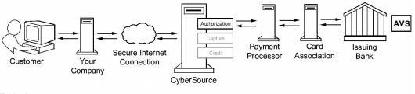

1. The customer places an order and provides the credit card number, the card expiration date, and other information about the card.

2   You send a request for authorization over a secure Internet connection. If the customer buys a digitally delivered product or service, you can request both the authorization and the capture at the same time. If the customer buys a physically fulfilled product, do not request the capture until you ship the product.

3   CyberSource validates the order information, and then contacts your payment processor and requests authorization.

4   The processor sends the transaction to the card association, which routes it to the issuing bank for the customer’s credit card. Some card companies, including Discover and American Express, act as their own issuing banks.

5   The issuing bank approves or declines the request. Depending on the card type, the bank could also use the Address Verification Service (AVS) to determine whether the customer provided the correct billing address. For more information about AVS, refer to AVS service documents via the CyberSource Services Documentation at <http://www.cybersource.com/support_center/support_documentation/services_documentation/payment.php> or as described in this integration guide.

6   CyberSource runs its own tests, and then tells you if the authorization succeeded.

7   Response is sent back to the client.

### Taxes

Online Customer adds Product(s) to Cart and proceeds to Checkout.

As soon as shipping information is entered and validated, taxes are updated to reflect current tax rates based on six basic criteria:

1. Customer ship to address
2. Merchant ship from address
3. Merchant point of order origin (POO)
4. Merchant point of order acceptance (POA)
5. Product code
6. Merchant nexus

Product information is provided on an individual line item basis and all merchant/request IDs are captured for future reference. When the customer enters in shipping information, the Tax Service is called to calculate taxes.

### Address Verification Service (AVS)

AVS does not exist as a stand-alone callable service. Please refer to the Credit Card Authorization Service walkthrough for high level walkthrough.

### Delivery Address Verification Service (DAV)

DAV service may be run as a stand-alone callable service, as well as be performed as a part of other services. Please refer to Credit Card Authorization Service for more information regarding the DAV service, as an integral part of payment auth.

As a stand-alone service, the process is defined as:

* Customer enters shipping information
* Shipping information passes client-side validation (required elements filled in)
* Shipping information passes basic server-side validation (syntactically correct)
* Request is made to CyberSource DAV Service
* Response returns DAVReasonCode (100=Success)
* Method returns either: authorized, declined or error (authorized==success, declined==failure)
* Captured validation information is extracted from arguments to present user with choices to correct problems, confirm “standardized” formatting or try again
* If service is successful, allow Shipping Address save operation to continue

### Decision Manager

The CyberSource Decision Manager provides Merchant and ability to set business rules, provide case management, and Reporting.

The CyberSource Decision Manager Business rule engine allows Merchant to analyze the order data based on predefined or custom rules. The business rules can be set by orders, by category, or by SKU.

The Demandware CyberSource Cartridge is using an alternate “Conversion Detail Report” Job

### Conversion Detail Report

Cyber Source Conversion report contains the results of the modified orders which were initially in review state. This information gives you an overview of all orders that were not immediately accepted. For each order that is initially marked review and later modified to accept or reject, the report contains below information:

* Request ID
* Status before and after review
* Name of reviewer
* Queue assignment
* Reviewer comments and notes
* Order profile

Request this report at any time during the day, starting up to 24 hours in the past and ending at the present time

The section “Configure Services” has details to configure conversion detail report cybersource service.

The section “Business Manager Changes for batch Jobs” has details about the conversion detail report batch Job, which fetches the last 24 hours updated order status from REVIEW to ACCEPT/REJECT within cybersource and further updates the order status in Demandware accordingly.

### Payment Tokenization

Tokenization is the replacement of sensitive data with a unique identifier that cannot be mathematically reversed. In your environment, tokens take the place of sensitive credit card data. Typically, the token will retain the last four digits of the card as a means of accurately matching the token to the payment card owner. The remaining numbers are generated using proprietary tokenization algorithms.

How It Works

* To make a purchase on your website, the customer will enter their payment card information into the designated payment fields on the order page. These payment fields will be hosted by CyberSource using [Hosted Payment Acceptance](http://www.cybersource.com/products_and_services/payment_security/hosted_payment_acceptance/). When the customer hits the ‘submit’ button, the data is immediately encrypted and transmitted directly to CyberSource for storing, processing, and token generation. The payment data never enters your environment.
* The encrypted primary account number (PAN) is decrypted when it enters CyberSource’s Level 1, PCI-compliant data vault, where it is securely stored. The payment data is then passed on to the processing channel (bank) and returned to CyberSource with an accepted or denied result.
* CyberSource returns the result to you but substitutes the PAN data with a uniquely generated token. You store the token in your database of record system (such as ERP system) for future transactions or chargeback resolution on that account. Customer service representatives can easily verify customers as the custom token will retain the last four digits of the original PAN.

### Payer Authentication

CyberSource Payer Authentication services enable you to add support to your web store for card authentication services, including Visa Verified by VisaSM, MasterCard® and Maestro® SecureCode™ (UK Domestic and international), American Express SafeKeySM, and JCB J/Secure™.

These card authentication services deter unauthorized card use and protect you from fraudulent chargeback activity referred to as *liability shift*.

How It Works

Payer Authentication provides the following services:

* + **Check Enrollment**: Determines whether the customer is enrolled in one of the card authentication programs.
  + **Validate Authentication**: Ensures that the authentication that you receive from the issuing bank is valid.



The Check Enrollment service determines whether the customer is enrolled in one of the

Card authentication services:

* **No**: If the card is not enrolled, you can process the authorization immediately.
* **Yes**: If the card is enrolled, the customer’s browser displays a window where the customer can enter the password associated with the card. This is how the customer authenticates their card with the issuing bank.
* If the password matches the password stored by the bank, you need to verify that the information is valid with the Validate Authentication service. If the identity of the sender is verified, you can process the payment with the Card Authorization service.
* If the password does not match the password stored by the bank, the customer may be fraudulent. You must refuse the card and can request another form of payment.

### Full Authorization Reversal

A full authorization reversal is a follow-on transaction that uses the request ID returned from a previous authorization. The request ID links the full authorization reversal to the authorization. CyberSource uses the request ID to look up the customer’s billing and account information from the original authorization, which means merchant is not required to include those fields in full authorization reversal request.

### Retail Point-of-Sale (POS)

This service of CyberSource enables a merchant to process a credit card for retail point-of-sale transaction at their stores. The integration takes inputs for the API service and provides CyberSource API response for later use. This integration takes care for terminal which has manual entry for credit card details and terminal with a magnetic stripe where a credit card can be swiped and enter amount for the transaction.

### AliPay Authorization

The Alipay authorization service allows storefront application to request for authorization for total ordered amount along with the currency. This make the web service call to CyberSource Alipay initiate service to initiate payment request and authorize the amount and after successful initiation controller make the web service call to check the payment status of initiated request.

The Demandware CyberSource- AuthorizeAlipay populates the payment initiate request with purchase total data, product name, product description and Alipay Payment type such as APD (Domestic payment for China based merchant to trade in China) and APY (International payment for International merchant to trade from outside China) and invoke the initiate web service call using CyberSource web service API.

**Alipay Authorization Sequence Flow:**

1. Create CyberSource Alipay Initiate request using purchase total data, product name, and product description (optional) from the current order object
2. Set Alipay payment type to domestic or international in site preference
3. After configuration make actual service call to Alipay Initiate request
4. Validate Reason code and Decision of Initiate request and accordingly set the corresponding variables.
5. If initiation is successful, then assign the required values in Demandware Payment Transaction object and create CyberSource Alipay Check Status Request using Request ID of Initiate service response
6. Make service call to Alipay Check Status request to return the payment status of initiated request
7. Validate Reason Code and Payment status of check status service response and set the corresponding variables
8. If ReasonCode = 100 then check the payment status. If payment status is COMPLETED for service call then complete the checkout flow and place the order with “New” as order status and “Paid” as order payment status.
9. If ReasonCode = 100 and PaymentStatus = PENDING, complete the checkout flow with order status as “Created” and order payment status as “Not Paid”.
10. If ReasonCode = 100 and PaymentStatus = ABANDONED or PaymentStatus = TRADE_NOT_EXIST, fail the order and show message on the screen.
11. If Decision = REJECT and ReasonCode = 102 or ReasonCode = 233, fail the order and show message on the screen.
12. If Decision = ERROR and ReasonCode = 150, fail the order and show message on the screen.

**Note:** As Alipay live environment is not available, so for Alipay Domestic and International scenarios, Site Preference configuration for Reconciliation ID needs to configure to test various scenarios of Alipay Initiate and Check Status service. Also, If shopper does not return from the AliPay then Demandware order status shall remain the same as “Created” and shall be updated once Batch Job for Check Payment Status service runs from scheduler

### Alipay Batch Job

Alipay batch job process Demandware orders placed by Alipay as payment method by making web service call to Alipay Check Status Service.

The Demandware CYBERSOURCE_ALIPAY_JOB-AlipayCheckPaymentStatusWorkflow pipeline node is called from batch job that populates the check status request with Request ID generated and stored in Demandware Payment Transaction custom attribute after Alipay Initiate request service call for every order placed by Alipay as payment method and invoke the Check Status web service call using CyberSource web service API.

**Alipay Batch Job Sequence Flow:**

1. Query on all the Demandware orders placed through Alipay with New, Open and Created as order status and get the Request Id stored in Order Payment Transaction custom object attribute after Alipay Initiate web service call.
2. Pass the Request Id and Payment Type to Alipay Check Status Service and make the actual service call.
3. Validate Reason Code and Payment status of check status service response and set the corresponding variables
4. If ReasonCode = 100 then check the payment status. If payment status is COMPLETED for service call then update the order status to “New”, Order Payment Status to “Paid”, Alipay Payment Status to “COMPLETED” in Order Payment Transaction custom object attribute and set the export status to “Ready For Export”
5. If ReasonCode = 100 and PaymentStatus = PENDING, no need to update any Demandware status in case of PENDING Alipay Payment Status.
6. If ReasonCode = 100 and PaymentStatus = ABANDONED or PaymentStatus = TRADE_NOT_EXIST, fail the order.
7. If Decision = REJECT and ReasonCode = 102 or ReasonCode = 233, fail the order.
8. If Decision = ERROR and ReasonCode = 150, fail the order.

### Secure Acceptance Authorization

Secure Acceptance payment gateway is used to process transaction requests directly from the customer browser so that sensitive payment data does not pass through Demandware servers.

Secure Acceptance feature is implemented using these secure acceptance payment methods:

1. Secure Acceptance – Redirect
2. Secure Acceptance – Iframe
3. Secure Acceptance – Silent Post

All the above secure Acceptance methods provide a common feature of handling the secure information on secure pages only.

**Secure Acceptance Redirect:** Customer will get redirect to secure Acceptance payment gateway when clicking on Place Order from Review Page

**Secure Acceptance Iframe:** Customer will get redirect to secure Acceptance payment gateway within an Iframe embedded in a new summary page added into checkout flow

**Secure Acceptance Silent Order Post:** Credit Card form data is posted to secure acceptance silent post URL and token is generated and user is redirected on review page and normal card authorization flow is being used to further process the transaction.

Secure Acceptance Web/Mobile Authorization Sequence flow:

1. Secure Acceptance Authorize create Request signature using signed and unsigned field names to validate the request on secure pages
2. Post the request data[i.e: billing/shipping/card details, signature in signed and unsigned fields] in to selected APM form Action
3. Secure Acceptance validate the request using signature and open the secure payment pages to complete the checkout flow
4. After successful checkout completion ,Customer is return back to Demandware custom controller method[configured in Cybersource profile]
5. Secure Acceptance response method get the response in CurrentHttpParameterMap,again signature is created using the response data and matched with the response signature, once validated response is parsed
6. Based on Decision and reason code Order will get placed or failed in Demandware.

Secure Acceptance Silent Order Post Authorization Sequence flow:

1. An Ajax function is created to call Secure Acceptance silent post controller to prepare request data except card details
2. Card details are populated within Ajax to prevent security breach , further the details are posted to selected APM form action URL
3. Silent post will create or update token based on request details and return the response on Demandware custom controller method which parse the response of CurrentHttpParameterMap and return back to corresponding pages[summary/billing/cart]
4. On Place Order ,Secure Acceptance authorization is called which internally completed the flow using CyberSource Authorization[refer Credit Card Authorization service]

### Secure Acceptance Merchant Notification Post Batch Job

The batch job process merchant post notifications arrived from cybersource secure acceptance web/mobile. These notification response data get stored in demandware custom object “SA_MerchantPost”.

Further when batch job runs it update those orders which did not got updated in regular customer checkout journey due to network issues. The job process below scenarios

1.       Order already updated in the checkout journey itself then custom object entry removed for order

2.       Order not updated in checkout journey then merchant post response read from custom object in JSON form and information updated in the order

a.       Billing/shipping address

b.      Order status as New/Failed

c.       Payment authorization response

d.      Card get saved for logged in user if customer opted in checkout journey

Note: It is recommended to have the batch job frequency every 15 min to update order status and release inventory

### Apple Pay

Developed REST Interface as standalone services and cartridge does not have end-to-end direct integration with DW native ApplePay Web/APP functionality. However interface has mechanisms to integrate individual methods with DW Native ApplePay web/APP

There are two type of REST interface supported where information expected in request are:

1.         Payload and order Number data

2.         Network Token, Order Number, Card type, Token Expiration Date, and cryptogram data

### Visa Checkout

Visa Checkout and the CyberSource credit card services work together as an integrated offering. CyberSource provides the following services to assist with your Visa Checkout integration

* Get Visa Checkout data: this service retrieves Visa  Checkout data, which  enables you to display payment and shipping details to the customer during checkout.
* Authorization: this service enables you to send an authorization request to your processor using the Visa Checkout payment data

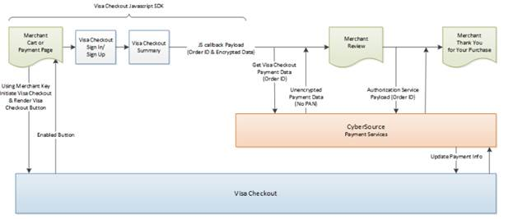

1.       Your web site integrates directly to Visa Checkout to display the Visa Checkout button on your checkout page.

2.       CyberSource provides the get Visa Checkout data service, which retrieves the Visa Checkout payment data, except the PAN. You can use the retrieved data to help the customer confirm the purchase.

3.       You submit an authorization request to CyberSource for credit card processing. Instead of including payment information in the authorization request, you include the Visa Checkout order ID.

4.       At various points in the transaction cycle, you notify the customer of the transaction status.

## Use Cases Scenarios

### Credit Card / VisaCheckout / ApplePay Authorization

The following table outlines the possible Demandware actions based on the response of the CyberSource gateway. Each client may choose to handle the response code differently. As of release 2.10, all errors logged as “fatal”, can activate an email alert to recipients identified in business manager.

|  |  |  |  |
| --- | --- | --- | --- |
| **Response** | **DW Storefront Action** | **Cyber-**  **Source Code** | **CyberSource suggested response** |
|  |  |  |  |
| Successful transaction. | Continue Checkout | 100 |  |
|  |  |  |  |
| **Validation Errors** | | | |
| Request is missing one or more fields | Should not occur as validation should catch this Show user “denied” error message Log fatal error (email alert) | 101 | See the reply fields missingField_0...N for which fields are missing. Resend the request with the complete information. |
|  |  |  |  |
|  |  |  |  |
| One or more fields in the request contain invalid data. | Should not occur as validation should catch this Show user “denied” error message Log fatal error (email alert) | 102 | See the reply fields invalidField_0...N for which fields are invalid. Resend the request with the correct information. |
|  |  |  |  |
| **System Errors** | | | |
| General system failure. | Show user “Unable to process – Call Cust Service” error message Log fatal error (email alert) | 150 | Wait a few minutes and resend the request. |
|  |  |  |  |
|  |  |  |  |
| The request was received but there was a server time-out. | Show user “Unable to process – Call Cust Service” error message Log fatal error (email alert) | 151 | Wait a few minutes and resend the request. |
|  |  |  |  |
|  |  |  |  |
| The request was received but there was a service time-out. | Show user “Unable to process – Call Cust Service” error message Log fatal error (email alert) | 152 | Wait a few minutes and resend the request. |
|  |  |  |  |
| The request just wait and then timeout, ends up as exception on the Demandware script | This could be one of the unique scenarios where CyberSource waits for the Merchant’s bank to authorize the order and exceeds timeout sets at the Demandware. This ends up into SOAP exception. Client code can handle this scenario differently. | Script sets Reason Code to 999 | Handle at client’s end depending on business rules associated with this scenario. |
|  |  |  |  |
| **Authorization denied errors** | | | |
| Declined the request because the card has expired. | Show user “Auth denied” error message | 202 | Request a different card or another form of payment. |
|  |  |  |  |
|  |  |  |  |
|  |  |  |  |
| The account number is invalid. | Show user “Auth denied” error message | 231 | Request a different card or other form of payment. |
|  |  |  |  |
| **Gateway Account problem** | | | |
| There is a problem with your merchant configuration. | Show user “Unable to process – Call Cust Service” error message Log fatal error (email alert) | 234 | Do not resend the request. Contact Customer Support to correct the configuration problem. |
|  |  |  |  |
| **Fraud Management** | | | |
| The fraud score exceeds your threshold. | Show user “Unable to process – Call Cust Service” error message Log fatal error (email alert) | 400 |  |
|  |  |  |  |
| The order is marked for review by Decision Manager. | Proceed with checkout Leave DW order “unconfirmed” | 480 |  |
|  |  |  |  |
| The order is rejected by Decision Manager. | Show user “Unable to process – Call Cust Service” error message Log fatal error (email alert) | 481 |  |

### Taxes

List of use cases and appropriate action taken listed below:

|  |  |
| --- | --- |
| **Use case scenarios** | **Result** |
| If shipping information is specified, then request is made to the Tax Service | If successful, the contents of the Basket are taxed and price totals are adjusted.  If failed, because of service outage or failed address verification then don’t update anything. Other services must handle AVS/DAV/Service outages before successful checkout and final sales tax calculation. Failure is logged for email notification. |
| Since cybersource charges per request to the tax service, the cartridge has been modified to reduce the number of tax requests. Subsequent tax requests in the current session are only made to cybersource if the line item’s products id, quantity or price has changed or if the basket merchandise price total (including order level and product level), adjusted shipping price totals or adjusted basket total price has changed. | If the basket state that would affect tax has changed then a tax call will be made to cybersource and the basket will be updated with the new tax prices.  If the basket state that would affect tax has not change, the request to cybersource is skipped. |

### Address Validation Service (AVS)

Note that AVS does not run as an independent process, but is instead an optional, integrated aspect of payment authorization. List of use cases and appropriate action taken listed below:

|  |  |
| --- | --- |
| **Use case scenarios** | **Result** |
| AVS Ignore Result set to true | AVS Information is captured, but does not affect authorization response. |
| AVS Ignore Result set to false | AVS information is captured and if result from AVS is error or declined, then propagates that result up to the calling service. |
| AVS Ignore Result is set to false & AVS Decline Flags is defined | Seed request with additional result codes which should also result in a declined response. |

### Delivery Address Verification Service (DAV)

List of use cases and appropriate action taken listed below:

|  |  |
| --- | --- |
| **Use case scenarios** | **Result** |
| DAV Enable is set to false | No DAV information will be requested. No correction/validation information will be collected from the response. |
| DAV Enable is set to true, DAV On Failure set to REJECT | DAV information will be requested from the calling service. DAV related corrections and validation information is captured, and a DAV-related failure will be propagated to the calling service. |
| DAV Enable is set to true, DAV On Failure set to APPROVE | DAV information will be requested from the calling service. DAV related corrections and validation information is captured, but the result does not affect Authorization result. |

### Conversion Detail Report

This job pick orders which are initially having decision as REVIEW in cybersource and later their decision modified as “ACCEPT” or “REJECT” in last 24 hours. The order status is updated in Demandware through the incoming xml of conversion detail report.

List of use cases and appropriate action taken listed below:

|  |  |
| --- | --- |
| **Use case scenarios** | **Result** |
| Incoming order status is set to “ACCEPT” | Read order from the order table; Update the status in demandware  The order statuses modified after conversion detail report ran successfully  Order Confirmation Status as CONFIRMED  Order Status as NEW/OPEN  Export Status as Ready For Export |
| Incoming order status is set to “REJECT” | Read order from the order table; update the status in demandware  The order statuses modified after conversion detail report ran successfully  Order Status as CANCELLED |

### Payment Tokenization

Payment Tokenization service stores the customer and card related sensitive data for future reuse. Updates order object with the subscription id received from Cybersource. Now tokenization will work along with Payer Authorization as well.

List of use cases and appropriate action taken listed below:

|  |  |
| --- | --- |
| **Use case scenarios** | **Result** |
| Create subscription response is set to “ACCEPT” | Place the order and update the order object with subscription id.  The subscription ID to be updated in field creditCardToken, this field not visible in BM order , though it is visible under order export XML file inside tag <CrdetCardToken> |
| Create subscription response is set to “REJECT” | Place the order but leave the subscription field empty. Make entry in log files to record the event. |

### Payer Authorization

List of use cases and appropriate action taken listed below:

|  |  |
| --- | --- |
| **Use case scenarios** | **Result** |
| Enrolment Check Error | Merchant proceeds to authorization (optional) |
| Cardholder Not Participating | Merchant proceeds to authorization |
| Unable To Verify Enrolment | Merchant proceeds to authorization (optional) |
| Successful Authentication | Merchant proceeds to authorization |
| Authentication Failure | Merchant asks for another form of payment |
| Attempted Authentication | Merchant proceeds to authorization |
| Authentication Unavailable | Merchant proceeds to authorization (optional) |
| Invalid Authentication Response | Merchant asks for another form of payment |
| PARes Signature Error | Merchant asks for another form of payment |
| Whitespace in PARes | Merchant proceeds to authorization |

### Retail Point-of-Sale (POS)

The use case for POS can be achieved by two scenarios:

1. Hardware - swipe credit card – (A Bluetooth scanning device must be paired to the iPad device.)

On Payments page, we listen for credit card swipes only after the user has entered the amount for Credit Card and tapped enter.

**Expected Result**: The swiped credit card is read and payment is made to the order

1. **Hardware - manually enter credit card with keypad**: (A Bluetooth scanning device must be paired to the iPad device.)

From Payments page, enter amount to be applied to credit card.

**Expected Result:** Manually enter credit card number on device and payment is accepted

### Alipay Authorization

The following table outlines the possible Demandware actions based on the response of the CyberSource gateway. Each client may choose to handle the response code differently.

|  |  |  |  |
| --- | --- | --- | --- |
| **Response** | **DW Storefront Action** | **CYB Code** | **CYB Suggested response** |
| Successful transaction. | Continue Checkout | 100 |  |
| **Validation Errors** | | | |
| Request is missing one or more fields | Should not occur as validation should catch this Show user “denied” error message Log error message into Demandware logs | 101 | See the reply field’s missingField_0...N for which fields are missing. Resend the request with the complete information. |
| One or more fields in the request contain invalid data. | Should not occur as validation should catch this Show user “denied” error message Log error message into Demandware logs | 102 | See the reply field’s invalidField_0...N for which fields are invalid. Resend the request with the correct information. |
| General decline by the processor | Should not occur as validation should catch this Show user “denied” error message Log error message into Demandware logs | 233 | Request that the customer select a different form of payment. |
| **System Errors** | | | |
| General system failure. | Show user “Unable to process – Call Customer Service” error message Log fatal error | 150 | Wait a few minutes and resend the request. |
| The request just wait and then timeout, ends up as exception on the Demandware script | This could be one of the unique scenarios where CyberSource waits for the Merchant’s bank to authorize the order and exceeds timeout sets at the Demandware. This ends up into SOAP exception. Client code can handle this scenario differently. | Script sets Reason Code to 999 | Handle at client’s end depending on business rules associated with this scenario. |

### Secure Acceptance Authorization

Following are the list of reason codes received for Secure Acceptance payment service response. System shall be handling these codes and change the Demandware status accordingly.

|  |  |  |
| --- | --- | --- |
| **Decision** | **Description** | **CYB hosted Decision** |
| Successful transaction. | Successful transaction. Reason codes 100 and 110. | 100 |
| Request is missing one or more fields | Authorization was declined; however, the capture may still be possible. Review payment details. See reason codes 200, 201, 230, 480, and 520. | 101 |
| One or more fields in the request contain invalid data. | Transaction was declined. See reason codes 102, 202, 203, 204, 205, 207, 208, 210, 211, 221, 222, 231, 232, 233, 234, 236, 240, 475, 476, and 481. | 102 |
| General decline by the processor | Access denied, page not found, or internal server error. See reason codes 102, 104, 150, 151 and 152 | 233 |
| General system failure. | The customer did not accept the service fee conditions. ν The customer cancelled the transaction. | 150 |
| Create Token Service | Silent Post Service for create token when user enter card details on billing page on merchant site | 100 |
| Update Token Service | Silent Post Service for create token when user choose existing saved cards on billing page on merchant site | 100 |
| Authorization and Create Token Service | Redirect or Iframe service for Authorization and create token when no saved card is choosen | 100 or 480 |
| Authorization and update Token Service | Redirect or Iframe service for Authorization and create token when user choose saved card | 100 or 480 |
| Authorization Service | Redirect or Iframe service for Authorization when tokenization is disabled from BM | 100 or 480 |

### VISA Checkout Decrypt

List of use cases and appropriate action taken listed below:

|  |  |  |
| --- | --- | --- |
| **Service** | **Description** | **CYB hosted Decision** |
| Decrypt | Accept – review page displayed decrypted details | 100 |
| Decrypt | Error -  System – user redirect to cart page with standard error message | 150 |
| Authorization | Behavior would remain same as card flow, where confirmation page displayed on successful authorization and review page with error message in case of error | Same as Credit Card Reason code |

### Credit Card Order Status Mapping with Demandware Order

|  |  |  |  |  |
| --- | --- | --- | --- | --- |
| **CYB Status** | **Order Status** | **Confirmation status** | **Payment status** | **Export status** |
| Auth/Accept | New/Open | Confirmed | Not Paid | Ready for export |
| Capture | New/Open | Confirmed | Paid |  |
| Pending/Review | Created | Not Confirmed | Not Paid | Not Exported |
| Reject/Decline | Failed | Not confirmed | Not Paid | Not Exported |

## Limitations, Constraints

Not currently implemented:

* Multiple shipments.  Tax rates are only calculated for a single shipment per order.  To implement tax service calculation for multiple shipments, a separate web service call must be made for each distinct “ship to” location.
* Custom User Interface components to correct address validation (DAV/AVS) errors and/or omissions or to confirm “standardized” address format corrections.  All pertinent data is collected, but because each merchant will have customized specifications how to deal with such information (or use other 3rd party solutions to play the same role); no default user interface is provided.
* Custom user interface for view, update and delete subscription. All functionalities are created and working in stand-alone mode in **CybersourceUnitTesting.js** controller. They have to customized and integrated as per the merchant specific needs.
* Custom user interface for Full Authorization Reversal. Full Authorization reversal is created and working in stand-alone mode in **CybersourceUnitTesting.js controller**. It has to customized and integrated as per the merchant specific needs.
* Cartridge does not provide changes to support the styling of error and validation messages. Merchant need to make the required changes to meet the style guide for error and validation messaging as per their storefront implementation
* Cartridge support s DW provided form field validations only
* Cartridge is tested for en_US locale only

Currently implemented with limitations and constraints:

* Testing of Alipay is possible only with Test data provided by CyberSource such as Reconciliation ID that is getting passed to Alipay Initiate Service to get the response back. We don’t have Alipay simulator and access to Alipay live environment.
* CNY is the only hardcoded currency value that has been used for Alipay Domestic requests.
* Incase user has enabled Decision Manager from CyberSource console for cards, its mandatory to enable Decision Manager from Business Manager Site Preference path: Site -> Site Preferences -> Custom Preferences -> Cybersource -> Decision Manager Enable for Card -> check/uncheck as per decision manager enabled/disabled in CyberSource console.
* Merchant to decide “Master Card Auth Indicator” as “Pre Authorization” “FinalAuthorization ” or “Undefined” from site preferences for master card.
* Order should remain in same state if user closes the browser while transaction is in progress. For example: For Alipay, if user closes the browser while coming back from simulator and before coming to order confirmation page, order will remain in created state.
* Unit Test Services are developed for the standalone testing purpose only and should not be used directly into production
* Cybersource must take into account Fraud and Risk details, AVS and card security codes available in PayLoad during transaction authorization, Cartridge will not be performing any additional security/risk checks except the existing CC Auth response handling
* Secure Acceptance:
  1. Limit storefront order setting must be disable if Merchant post URL is configured
  2. Cartridge supports five types of cards in secure acceptance (Visa, master card, amex, maestro international, discover)
* Visa Checkout:

1. “Save Card” option will not be available in the demandware checkout journey, which means tokenization will not be applicable for Visa Transactions

* Apple Pay  REST Interface:

1. Tokenization and Payer authentication is not supported with ApplePay Transactions
2. Developed REST Interface  are just standalone services only and does not support direct integration with DW native ApplePay Web functionality, however interface is developed in such a way that Merchant can use individual methods to integrate with DW Native ApplePay web

## Compatibility

This cartridge is supported under Demandware Site genesis release code base 17.1 and compatability mode of 16.2

# Implementation Guide

## Custom Code

Modify the references of actual storefront cartridges in cybersource cartridges during cybersource integration. Cybersource cartridge is developed assuming storefront cartridge naming conventions as:

* + - app_storefront_core
    - app_storefront_controllers

### Generic Section

#### Controller - COPlaceOrder.js

##### Update “handlePayments” Function

1. This function use for invoke payment processor Authorize function and check the result
2. Check for the result of authorization as failed
3. Return authorization result rather than empty when there is no error occurred

|  |
| --- |
| **function** handlePayments(order) {  **var** authorizationResult ={};  **if** (order.getTotalNetPrice() !== 0.00) {  **var** paymentInstruments = order.getPaymentInstruments();  **if** (paymentInstruments.length === 0) {  **return** {  missingPaymentInfo: **true**  };  }  /**  * Sets the transaction ID for the payment instrument.  */  **var** handlePaymentTransaction = **function** () {  paymentInstrument.getPaymentTransaction().setTransactionID(order.getOrderNo());  };  **for** (**var** i = 0; i < paymentInstruments.length; i++) {  **var** paymentInstrument = paymentInstruments[i];  **if** (PaymentMgr.getPaymentMethod(paymentInstrument.getPaymentMethod()).getPaymentProcessor() === **null**) {  Transaction.wrap(handlePaymentTransaction);  } **else** {  authorizationResult = PaymentProcessor.authorize(order, paymentInstrument);  **if** (authorizationResult.not_supported || authorizationResult.error || authorizationResult.failed) {  **return** {  error: **true**  };  } else if(authorizationResult.returnToPage){  return {  returnToPage :true,  order : order  };  }  }  }  }  **return** authorizationResult;  } |

##### Update “start” function to handle payment results

Add below snippet to handle payment different results

|  |
| --- |
| var handlePaymentsResult = handlePayments(order);  if (handlePaymentsResult.error) {  session.custom.SkipTaxCalculation=false;  return Transaction.wrap(function () {  OrderMgr.failOrder(order);  return {  error: true,  PlaceOrderError: new Status(Status.ERROR, 'confirm.error.technical')  };  }); |

|  |
| --- |
| } **else** **if** (handlePaymentsResult.missingPaymentInfo) {  session.custom.SkipTaxCalculation=**false**;  **return** Transaction.wrap(**function** () {  OrderMgr.failOrder(order);  **return** {  error: **true**,  PlaceOrderError: **new** Status(Status.ERROR, 'confirm.error.technical')  };  });  }  } else if (handlePaymentsResult.declined) {  session.custom.SkipTaxCalculation=false;  return Transaction.wrap(function () {  OrderMgr.failOrder(order);  return {  error: true,  PlaceOrderError: new Status(Status.ERROR, 'confirm.error.declined')  };  });  } else if (handlePaymentsResult.end) {  return {};  } else if (handlePaymentsResult.review) {  ReviewOrder({Order:order});  return {};  } else if (handlePaymentsResult.pending) {  ReviewOrder({Order:order});  return {};  }  var orderPlacementStatus = Order.submit(order);  if (!orderPlacementStatus.error) {  clearForms();  }  return orderPlacementStatus;  } |

##### Update “clearforms” function

Add below snippet at end of function

|  |
| --- |
| session.custom.cartStateString=null; |

##### Add” fail” function

1. Add new method to handle the failed order

|  |
| --- |
| /*  * Identifies if an order exists, submits the order, and shows a confirmation message.  */  **function** fail(args) {  **var** Cybersource = require('int_cybersource_controllers/cartridge/controllers/Cybersource');  **var** orderResult = Cybersource.GetOrder({Order:args.Order});  **if** (orderResult.error) {  app.getController('COSummary').Start({PlaceOrderError:orderResult.PlaceOrderError});  **return**;  }  **var** order = orderResult.Order;  **var** PlaceOrderError = args.PlaceOrderError!= **null** ? args.PlaceOrderError : **new** dw.system.Status(dw.system.Status.ERROR, "confirm.error.declined");  session.custom.SkipTaxCalculation=**false**;  **var** failResult = Transaction.wrap(**function** () {  OrderMgr.failOrder(order);  **return** {  error: **true**,  PlaceOrderError: PlaceOrderError  };  });  **if** (failResult.error){  app.getController('COSummary').Start({PlaceOrderError:failResult.PlaceOrderError});  **return**;  }  **return**;  } |

##### Add “ReviewOrder” function

Add below lines at script module section

|  |
| --- |
| var Email = app.getModel('Email');  var Resource = require('dw/web/Resource'); |

Add the review order function with the code snippet below

|  |
| --- |
| /**  * Leave order in created state in demandware and send order confirmation email  * **@param** args  */  **function** ReviewOrder(args) {  **var** order = args.Order;  // Send order confirmation and clear used forms within the checkout process.  Email.get('mail/orderconfirmation', order.getCustomerEmail())  .setSubject((Resource.msg('order.orderconfirmation-email.001', 'order', **null**) + ' ' + order.getOrderNo()).toString())  .send({  Order: order  });  // Clears all forms used in the checkout process.  clearForms();  app.getController('COSummary').ShowConfirmation(order);  **return**;  } |

##### Add “submitOrder” function

Add the submit order function with the code snippet below

|  |
| --- |
| /**  * Submit the order and send order confirmation email  * **@param** args  */  **function** SubmitOrder(args) {  **var** orderPlacementStatus = Order.submit(args.Order);  **if** (!orderPlacementStatus.error) {  clearForms();  app.getController('COSummary').ShowConfirmation(args.Order);  **return**;  }    app.getController('COSummary').Start();  } |

##### Update “submit” function

Replace the submit function with the code snippet below

|  |
| --- |
| /*  * Asynchronous Callbacks for SiteGenesis.  * Identifies if an order exists, submits the order, and shows a confirmation message.  */  **function** submit(args) {  **var** Provider = require('int_cybersource_controllers/cartridge/controllers/Provider');  **var** providerParam = request.httpParameterMap.provider.stringValue;  **if**(!empty(providerParam)) {  **return** Provider.Check(args);  }  app.getController('Cart').Show();  **return**;  } |

##### Export functions

|  |
| --- |
| exports.Fail = guard.ensure(['https'], fail);  exports.ReviewOrder = ReviewOrder;  exports.SubmitOrder = SubmitOrder; |

#### Controller - COBilling.js

##### Update Export Function

|  |
| --- |
| exports.ReturnToForm = guard.ensure(['https'], returnToForm);  exports.handleBillingAddress = handleBillingAddress;  exports.initAddressForm = initAddressForm;  exports.initEmailAddress = initEmailAddress;  exports.validateBilling = validateBilling; |

##### Update “resetPaymentForms()” function

This fuction invoke cybersource cartridge “ResetPaymentForms” function after cart basket retrieved.

Remove BML payment instruments from paypal and credit card condition

Add if condition after cart object

|  |
| --- |
| /**  * Clears the form element for the currently selected payment method and removes the other payment methods.  *  * **@return** {Boolean} Returns true if payment is successfully reset. Returns false if the currently selected payment  * method is bml and the ssn cannot be validated.  */  **function** resetPaymentForms() {  **var** cart = app.getModel('Cart').get();  **if** (**null** != cart && !empty(app.getForm('billing').object.paymentMethods.selectedPaymentMethodID)) {  **var** Cybersource = require('int_cybersource_controllers/cartridge/controllers/Cybersource');  Cybersource.ResetPaymentForms({Basket:cart.object, PaymentType: app.getForm('billing').object.paymentMethods.selectedPaymentMethodID.value});  }  **var** status = Transaction.wrap(**function** () {  **if** (app.getForm('billing').object.paymentMethods.selectedPaymentMethodID.value.equals('PayPal')) {  app.getForm('billing').object.paymentMethods.creditCard.clearFormElement();  cart.removePaymentInstruments(cart.getPaymentInstruments(PaymentInstrument.METHOD_CREDIT_CARD));  } **else** **if** (app.getForm('billing').object.paymentMethods.selectedPaymentMethodID.value.equals(PaymentInstrument.METHOD_CREDIT_CARD)) {  cart.removePaymentInstruments(cart.getPaymentInstruments('PayPal'));  } **else** **if** (app.getForm('billing').object.paymentMethods.selectedPaymentMethodID.value.equals(PaymentInstrument.METHOD_BML)) {  app.getForm('billing').object.paymentMethods.creditCard.clearFormElement();  **if** (!app.getForm('billing').object.paymentMethods.bml.ssn.valid) {  **return** **false**;  }  cart.removePaymentInstruments(cart.getPaymentInstruments(PaymentInstrument.METHOD_CREDIT_CARD));  }  **return** **true**;  });  **return** status;  } |

##### Update the validateBilling() function

Update the if condition Code add highlighted section

|  |
| --- |
| **if** (!empty(app.getForm('billing').object.paymentMethods.selectedPaymentMethodID.value)  && app.getForm('billing').object.paymentMethods.selectedPaymentMethodID.value.equals(PaymentInstrument.METHOD_CREDIT_CARD)  && empty(app.getForm('billing').object.paymentMethods.creditCard.selectedCardID.value)) {  **if** (!app.getForm('billing').object.valid) {  **return** **false**;  }  } |

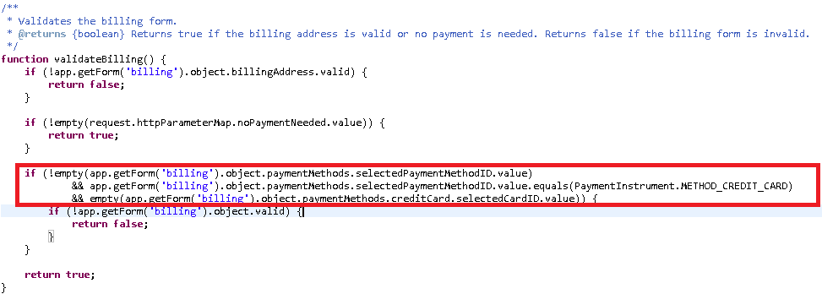

##### Update “saveCreditCard” function

Replace the entire function with the below snippet,.

|  |
| --- |
| **function** saveCreditCard() {  **var** Cybersource = require('int_cybersource_controllers/cartridge/controllers/Cybersource');  **return** Cybersource.SaveCreditCard();  } |

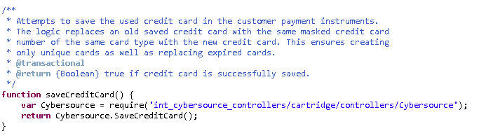

##### Update “selectCreditCard” function

Add below code snippet inside the condition for selectedCreditCard to update selectedcarduuid in Credit card

|  |
| --- |
| **if** (selectedCreditCard) {  app.getForm('billing').object.paymentMethods.creditCard.number.value = selectedCreditCard.getCreditCardNumber();  app.getForm('billing').object.paymentMethods.creditCard.selectedCardID.value = selectedCreditCard.UUID;  } |

#### JS file – billing.js [compiled to app.js]

##### Update “populateCreditCardForm” function

Add new parameter “selectedPaymentMethod” and add Switch condition to handle Credit card related APM’s as below:

[Note: all app.js changes are similar to billing.js, please refer the below section for app.js changes]

|  |
| --- |
| **function** populateCreditCardForm(cardID,selectedPaymentMethod) {  // load card details  **var** url = util.appendParamToURL(Urls.billingSelectCC, 'creditCardUUID', cardID);  ajax.getJson({  url: url,  callback: **function** 0028data) {  **if** (!data) {  window.alert(Resources.CC_LOAD_ERROR);  return false;  }  **switch** (selectedPaymentMethod) {  **case** "SA_REDIRECT":  $('.payment-method-expanded .saCCToken .field-wrapper').val(data.selectedCardID); $("#dwfrm_billing_paymentMethods_creditCard_selectedCardID").val(data.selectedCardID);  break;  **case** "SA_IFRAME":  $('.payment-method-expanded .saIframeCCToken .field-wrapper').val(data.selectedCardID); $("#dwfrm_billing_paymentMethods_creditCard_selectedCardID").val(data.selectedCardID);  break;  **case** "CREDIT_CARD":  setCCFields(data);  break;  default:  setCCFields(data);  }  }  });  } |

##### Update “creditCardList” on change function

* Update the method by adding parameter “selectedPaymentMethod”:

|  |
| --- |
| // select credit card from list  $('#creditCardList').on('change', **function** () {  **var** cardUUID = $(**this**).val();  **if** (!cardUUID) {$($checkoutForm).find('input[name$="_selectedCardID"]').val(''); **return**;}  populateCreditCardForm(cardUUID,selectedPaymentMethod);  // remove server side error  $('.required.error').removeClass('error');  $('.error-message').remove();  }); |

##### Update “setCCFields “function

* Add highlighted lines as shown in function

|  |
| --- |
| **function** setCCFields(data) {  **var** $creditCard = $('[data-method="CREDIT_CARD"]');  $creditCard.find('input[name$="creditCard_owner"]').val(data.holder).trigger('change');  $creditCard.find('select[name$="_type"]').val(data.type).trigger('change');  $creditCard.find('input[name*="_creditCard_number"]').val(data.maskedNumber).trigger('change');  **var** selectedPaymentMethodID = $('input[name$="_selectedPaymentMethodID"]:checked').val();  **if**(selectedPaymentMethodID == 'SA_SILENTPOST'){  $creditCard.find('[name$="_month"]').val(data.expirationMonth);  $creditCard.find('[name$="_year"]').val(data.expirationYear);  }  **else**{  $creditCard.find('[name$="_month"]').val(data.expirationMonth).trigger('change');  $creditCard.find('[name$="_year"]').val(data.expirationYear).trigger('change');  }  $creditCard.find('input[name$="_cvn"]').val('').trigger('change');  $creditCard.find('[name$="creditCard_selectedCardID"]').val(data.selectedCardID).trigger('change');  $creditCard.find("input[name$='_cvn']").val('');  } |

##### Update “updatePaymentMethod “function

* Add highlighted lines at end of function before validateform

|  |
| --- |
| **function** updatePaymentMethod(paymentMethodID) {  **var** $paymentMethods = $('.payment-method');  $paymentMethods.removeClass('payment-method-expanded');  **var** dataMethod = paymentMethodID;  **if** (paymentMethodID=='SA_SILENTPOST') {  dataMethod = 'CREDIT_CARD';  }  **var** $selectedPaymentMethod = $paymentMethods.filter('[data-method="' + dataMethod + '"]');  **if** ($selectedPaymentMethod.length === 0) {  $selectedPaymentMethod = $('[data-method="Custom"]');  }  **if** (paymentMethodID=="VISA_CHECKOUT") {  $(".continue-place-order").hide();  $(".visacheckoutbutton").show();  }  **else** {  $(".continue-place-order").show();  $(".visacheckoutbutton").hide();  }  **if** (paymentMethodID=="CREDIT_CARD" || paymentMethodID=="SA_SILENTPOST") {  $(".spsavecard").show();  } **else** **if** ((paymentMethodID=="SA_REDIRECT" || paymentMethodID=="SA_IFRAME") && SitePreferences.TOKENIZATION_ENABLED) {  $(".spsavecard").show();  }  **else** {  $(".spsavecard").hide();  }  $selectedPaymentMethod.addClass('payment-method-expanded');  // ensure checkbox of payment method is checked  $('input[name$="_selectedPaymentMethodID"]').removeAttr('checked');  $('input[value=' + paymentMethodID + ']').prop('checked', 'checked');  formPrepare.validateForm();  } |

##### Update “export.init “function

* Remove creditCardList onchange section and updatePaymentMethod section
* Add below code snippet after formPrepare.init

|  |
| --- |
| formPrepare.init({  formSelector: 'form[id$="billing"]',  continueSelector: '[name$="billing_save"]'  });  **var** $ccContainer = $($checkoutForm).find(".payment-method").filter(**function**(){  **return** $(**this**).data("method")=="CREDIT_CARD";  });  $($checkoutForm).find('input[name$="_selectedCardID"]').val('');  $($checkoutForm).find('input[name*="_number"]').val('');      $ccContainer.find('input[name*="_number"]').on('change',**function**(e){  $($checkoutForm).find('input[name$="_selectedCardID"]').val('');  });  $ccContainer.find('input[name$="_owner"]').on('change',**function**(e){  $($checkoutForm).find('input[name$="_selectedCardID"]').val('');  });  $ccContainer.find('select[name$="creditCard_type"]').on('change',**function**(e){  $($checkoutForm).find('input[name$="_selectedCardID"]').val('');  });    $ccContainer.find('select[name*="expiration"]').on('change',**function**(e){  $($checkoutForm).find('input[name$="_selectedCardID"]').val('');    **var** selectedPaymentMethodID = $('input[name$="_selectedPaymentMethodID"]:checked').val();  **var** cardNumber = $($checkoutForm).find('input[name*="_number"]').val();  **if**(cardNumber.indexOf('****') != -1 && selectedPaymentMethodID == 'SA_SILENTPOST'){  $($checkoutForm).find('input[name*="_number"]').val('');  }    });    **var** $ccNum = $ccContainer.find("input[name$='_number']"); // default payment method to 'CREDIT_CARD'  updatePaymentMethod((selectedPaymentMethod) ? selectedPaymentMethod : 'CREDIT_CARD');  $selectPaymentMethod.on('click', 'input[type="radio"]', **function** () {  updatePaymentMethod($(**this**).val());  }); |

#### Form - creditcard.xml

1. Include the following form field after saveCard field in the form:

|  |
| --- |
| <!-- field for credit card subscription -->  <field formid="selectedCardID" type="string" /> |

1. Remove max-length="16" from credit card number field to allow cards numbers of varied length.

|  |
| --- |
| <field formid=*"number"* label=*"creditcard.number"* type=*"string"* mandatory=*"true"* masked=*"4"* max-length=*"16"* description=*"creditcard.numberexample"* binding=*"creditCardNumber"* missing-error=*"creditcard.numbermissingerror"* value-error=*"creditcard.numbervalueerror"*/> |

#### Form - customeraddress.xml

Include the following code just above the action events

|  |
| --- |
| <!-- email field is contained in separate form group to enable binding to customer profile -->  <group formid=*"email"*>  <field formid=*"*emailAddress*"* label=*"profile.email"* type=*"string"* mandatory=*"true"* regexp=*"^[\w.%+-]+@[\w.-]+\.[\w]{2,6}$"* binding=*"email"* max-length=*"50"* missing-error=*"forms.address.email.invalid"* range-error=*"forms.address.email.invalid"* parse-error=*"forms.address.email.invalid"* value-error=*"forms.address.email.invalid"*/>  </group>  <!-- all possible actions performed on an address -->  <action formid="cancel" valid-form="false"/>  <action formid="remove" valid-form="false"/> |

#### Form - paymentinstruments.xml

Include address fromId just below new credit card Id

|  |
| --- |
| <include formid="address" name="customeraddress"/> |

#### Template - creditcardjson.isml

Retrieve subscription token of saved card to be used further

|  |
| --- |
| expirationYear:pdict.SelectedCreditCard.creditCardExpirationYear,  selectedCardID:pdict.SelectedCreditCard.UUID |

#### Template - paymentmethods.isml

##### Remove Credit card and bml payment method section and include custom logic for fields

* Include the following code

|  |
| --- |
| <isscript>  var currentCountry = require('~/cartridge/scripts/util/Countries').getCurrent(pdict);  </isscript>  <isinclude template="custom/paymentmethods"/> |

#### Template - paymentinstrumentdetails.isml

##### Remove attributes property fromcreditcardnumber field

|  |
| --- |
| <isinputfield formfield="${pdict.CurrentForms.paymentinstruments.creditcards.newcreditcard.number}" dynamicname="true" type="input" attributes="${numberAttributes}"/> |

#### Script - Resource.ds

##### Update ResourceHelper.getPreferences

|  |
| --- |
| ,TOKENIZATION_ENABLED: (Site.getCurrent().getCustomPreferenceValue('CsTokenizationEnable') == 'YES')? true : false |

#### Controller- common.js

##### Update validatePaymentInstruments function

Update below if condition so that expired card is not shown in saved credit card list during checkout.

|  |
| --- |
| if (card !== null && cards.contains(card) && !pi.isCreditCardExpired()) { |

### Credit Card Auth

#### Hooks.json in Controller

##### Replace hook entry for CYBERSOURCE_CREDIT

{

"name": "app.payment.processor.CYBERSOURCE_CREDIT",

"script": "./../../../int_cybersource_controllers/cartridge/controllers/CYBERSOURCE_CREDIT"

},

### Tax Service

#### Script - calculate.js

##### Avoid CalculateTax builtin Function Call for NET taxation

Move the built in tax calculation function call in cart/calculate.js inside condition below which is getting called from a custom hook in CalculateCart.ds.

|  |
| --- |
| **// ===================================================**  **// ===== CALCULATE TAX =====**  **// ===================================================**  **if** (dw.order.TaxMgr.taxationPolicy!=dw.order.TaxMgr.TAX_POLICY_NET) {  calculateTax(basket);  } |

#### Controller Cartridge – Script CartModel.js

##### Update Calculate function

Add condition for calling calculate taxes of cybersource after hook call

|  |
| --- |
| **if** (dw.order.TaxMgr.taxationPolicy==dw.order.TaxMgr.TAX_POLICY_NET) {  **var** Cybersource = require('int_cybersource_controllers/cartridbasicge/controllers/Cybersource');  Cybersource.CalculateTaxes({Basket:**this**.object});  }  },  addProductToCart: function() { |

#### Controller Cartridge – Script OrderModel.js

##### Update placeOrder function

1. Set variable session.custom.SkipTaxCalculation=false; before failOrder

|  |
| --- |
| **function** placeOrder(order) {  **var** placeOrderStatus = OrderMgr.placeOrder(order);  **if** (placeOrderStatus === Status.ERROR) {  session.custom.SkipTaxCalculation=**false**;  OrderMgr.failOrder(order);  **throw** **new** Error('Failed to place order.');  }  order.setConfirmationStatus(Order.CONFIRMATION_STATUS_CONFIRMED);  order.setExportStatus(Order.EXPORT_STATUS_READY);  } |

#### Controller -Cart.js

##### Update submitForm function

UpdatedeleteProct sdection by clear cartstatestring

|  |
| --- |
| 'deleteProduct': **function** (formgroup) {  Transaction.wrap(**function** () {  cart.removeProductLineItem(formgroup.getTriggeredAction().object);  session.custom.cartStateString = **null**;  });  **return** {  cart: cart  };  }, |

##### Controller – COShipping.js

###### Update “updateShippingMethodList“ function

1. Set session variable session.custom.SkipTaxCalculation=true;before cart calculate

|  |
| --- |
| applicableShippingMethods = cart.getApplicableShippingMethods(address);  shippingCosts = **new** HashMap();  currentShippingMethod = cart.getDefaultShipment().getShippingMethod() || ShippingMgr.getDefaultShippingMethod();    // Transaction controls are for fine tuning the performance of the data base interactions when calculating shipping methods  Transaction.begin();  **for** (i = 0; i < applicableShippingMethods.length; i++) {  method = applicableShippingMethods[i];  cart.updateShipmentShippingMethod(cart.getDefaultShipment().getID(), method.getID(), method, applicableShippingMethods);  session.custom.SkipTaxCalculation=true;  cart.calculate();  shippingCosts.put(method.getID(), cart.preCalculateShipping(method));  } |

##### Controller – COPlaceOrder.js

###### Update “start” function

1. Set session variable SkipTaxCalculation set as false in payment ERROR scenarios

session.custom.SkipTaxCalculation=false;

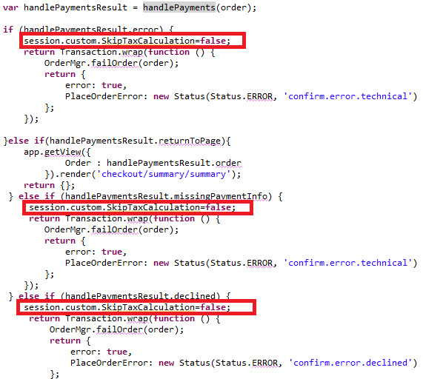

### Address Verification Service

Provide Site Preference values for 2 AVS-related business rules:

User can change the site preference value by following [Merchant Tools](https://cybersource04.tech-prtnr-na02.dw.demandware.net/on/demandware.store/Sites-Site/default/ViewApplication-SelectSite?MenuGroupID=ChannelMenu&ChannelID=bcbcIiaagtq3oaaac631602PJ3&SelectedSiteID=bcbcIiaagtq3oaaac631602PJ3) >  [Site Preferences](https://cybersource04.tech-prtnr-na02.dw.demandware.net/on/demandware.store/Sites-Site/default/SiteNavigationBar-ShowMenuitemOverview?CurrentMenuItemId=site-prefs) >  [Custom Site Preferences](https://cybersource04.tech-prtnr-na02.dw.demandware.net/on/demandware.store/Sites-Site/default/CustomPreferences-View?PreferenceType=SITE) > Cybersource path for a selected site as shown below.

CsAvsIgnoreResult – Determines whether AVS failures will force an auth failure.

Default value would be false and if user checks this checkbox then in case of address verification failure corresponding to AVS decline flags, order will be placed but considering the default value, in case of address verification failure corresponding to decline flags application will not allow user to place the order.

CsAvsDeclineFlags –Determines how “correct” an address must be to produce a failure result

Augment UI interaction nodes to deal with AVS failure or correction confirmation dialogs, wherever Payment Authorization takes place, typically within the COPlaceOrder-Start and COSummary-Submit.

Merchant can define the value of decline flags in the business manager Cybersource site preference and when address verification service is enabled and while placing the order if that service returns any of the flag mentioned in site preference, system will decline the order.

Screen shot to change the site preference value:

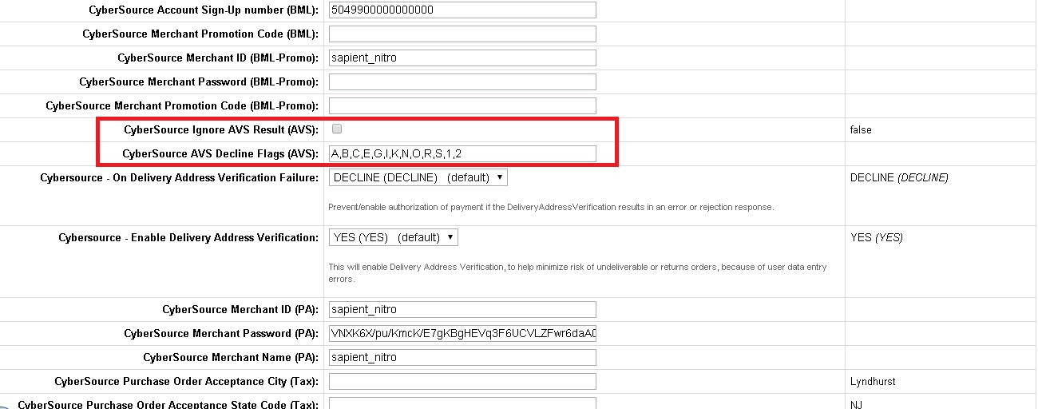

### Delivery Address Validation Service

Provide Site Preference values for 2 DAV-related business rules:

User can change the site preference value by following [Merchant Tools](https://cybersource04.tech-prtnr-na02.dw.demandware.net/on/demandware.store/Sites-Site/default/ViewApplication-SelectSite?MenuGroupID=ChannelMenu&ChannelID=bcbcIiaagtq3oaaac631602PJ3&SelectedSiteID=bcbcIiaagtq3oaaac631602PJ3) >  [Site Preferences](https://cybersource04.tech-prtnr-na02.dw.demandware.net/on/demandware.store/Sites-Site/default/SiteNavigationBar-ShowMenuitemOverview?CurrentMenuItemId=site-prefs) >  [Custom Site Preferences](https://cybersource04.tech-prtnr-na02.dw.demandware.net/on/demandware.store/Sites-Site/default/CustomPreferences-View?PreferenceType=SITE) > Cybersource path for a selected site as shown below.

CsDavEnable – Determines whether DAV features are enabled for payment auth requests.

Default value would be DECLINE and if user selects APPROVE from dropdown then in case of shipping or delivery address validation failure corresponding to enable delivery address verification value mentioned below, order will be placed but considering the default value i.e. DECLINE, in case of shipping or delivery address validation failure corresponding to enable delivery address verification value, application will not allow user to place the order. This will Prevent/enable authorization of payment if the DeliveryAddressVerification results in an error or rejection response.

CsDavOnAddressVerificationFailure –Determines whether a DAV failure will result in a payment auth failure

Merchant can set the value of this field in the business manager Cybersource site preference. This will enable Delivery Address Verification, to help minimize risk of undeliverable or returns orders, because of user data entry errors. When user selects YES from the drop down and corresponding CsDavEnable site preference value is DECLINE and in case of delivery address verification failure, system will not allow process the order.

Augment UI interaction nodes to deal with AVS failure or correction confirmation dialogs, wherever Payment Authorization takes place, typically within the COPlaceOrder-Start and COSummary-Submit.

Screen shot to change the site preference value:

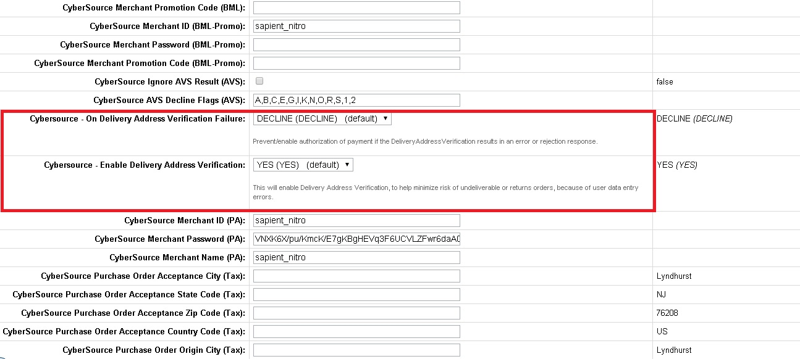

### Full Authorization Reversal

Full Authorization reversal is created and working in stand-alone mode in **CybersourceUnitTesting** .js controller. It has to customized and integrated as per the merchant specific needs.

### Payer Authentication Service

##### Configure Site preference

Provide Site Preference values for 5 Payment Authorization related business rules:

CyberSource Merchant ID (PA):– Determines which Cybersource merchant id to be used for payer authentication. It can be same as default merchant id as well.

CyberSource Merchant Password (PA): –Password corresponding to the merchant account.

CyberSource Merchant Name (PA): –Merchant Name to be used for service.

CyberSource Save Proof.xml (PA): –Determines whether to save proof.xml (received from Cybersource response) as part of order object.

CyberSource Save ParesStatus(PA): –Determines whether to pass ParesStatus received as input parameter from Pa authorization request as input parameter to ccAuthorization request.

### Payment Tokenization Service

#### My Account - Template - paymentinstrumentdetails.isml

##### Display Subscription Error Message

Include the following code block just after the <h1> tag to display the title message

|  |
| --- |
| <isif condition=*"${pdict.SubscriptionError != null}"*>  <div class=*"error-form"*>  ${Resource.msg('account.subscription', 'cybersource',null)}  </div>  </isif> |

##### Add Billing Address Fields

Include the below code right after <isdynamicform> form object

|  |
| --- |
| <!-- code comments for adding new billing fields..-->  <isinputfield formfield=*"${pdict.CurrentForms.paymentinstruments.creditcards.address.firstname}"* type=*"input"*/>  <isinputfield formfield=*"${pdict.CurrentForms.paymentinstruments.creditcards.address.lastname}"* type=*"input"*/>  <isinputfield formfield=*"${pdict.CurrentForms.paymentinstruments.creditcards.address.address1}"* type=*"input"*/>  <isinputfield formfield=*"${pdict.CurrentForms.paymentinstruments.creditcards.address.address2}"* type=*"input"*/>  <isinputfield formfield=*"${pdict.CurrentForms.paymentinstruments.creditcards.address.country}"* type=*"select"*/>  <isinputfield formfield=*"${pdict.CurrentForms.paymentinstruments.creditcards.address.states.state}"* type=*"select"*/>  <isinputfield formfield=*"${pdict.CurrentForms.paymentinstruments.creditcards.address.city}"* type=*"input"*/>  <isinputfield formfield=*"${pdict.CurrentForms.paymentinstruments.creditcards.address.postal}"* type=*"input"*/>  <isinputfield formfield=*"${pdict.CurrentForms.paymentinstruments.creditcards.address.phone}"* type=*"input"*/>  <isinputfield formfield=*"${pdict.CurrentForms.paymentinstruments.creditcards.address.email.emailAddress}"* xhtmlclass=*"email"* type=*"input"*/>  <!-- end code changes for billing fields. --> |

#### My Account - Template - paymentinstrumentlist.isml

##### Display Subscription Error

Add below code just after <h1> tag to show delete subscription message

|  |
| --- |
| <isif condition=*"${pdict.SubscriptionError != null}"*>  <div class=*"error-form"*>  ${Resource.msg('paymentinstrumentlist.deletesubscription','cybersource',null)}  </div>  </isif> |

#### My Account - Controller - PaymentInstruments.js

##### Update “list” function

Update as below to handle SubscriptionError

|  |
| --- |
| **function** list() {  **var** SubscriptionError=**null**;  **var** wallet = customer.getProfile().getWallet();  **var** paymentInstruments = wallet.getPaymentInstruments(dw.order.PaymentInstrument.METHOD_CREDIT_CARD);  **var** pageMeta = require('~/cartridge/scripts/meta');  **var** paymentForm = app.getForm('paymentinstruments');  paymentForm.clear();  paymentForm.get('creditcards.storedcards').copyFrom(paymentInstruments);  pageMeta.update(dw.content.ContentMgr.getContent('myaccount-paymentsettings'));  **if** (('SubscriptionError' **in** session.custom) && !empty(session.custom.SubscriptionError)) {  SubscriptionError = session.custom.SubscriptionError;  session.custom.SubscriptionError = **null**;  }  app.getView({  PaymentInstruments: paymentInstruments,  SubscriptionError : SubscriptionError  }).render('account/payment/paymentinstrumentlist');  **return**;  } |

##### Update “Add” function

Update as below to handle SubscriptionError

|  |
| --- |
| **function** add(clearForm, subscriptionError) {  **var** paymentForm = app.getForm('paymentinstruments');  **if** (clearForm !== **false**) {  paymentForm.clear();  }  paymentForm.get('creditcards.newcreditcard.type').setOptions(dw.order.PaymentMgr  .getPaymentMethod(dw.order.PaymentInstrument.METHOD_CREDIT_CARD).activePaymentCards.iterator());  app.getView({  ContinueURL: URLUtils.https('PaymentInstruments-PaymentForm'),  SubscriptionError: subscriptionError  }).render('account/payment/paymentinstrumentdetails');  } |

##### Update “handlePaymentForm” function

Update this code with **if** (!create()) {add(**false**); with below code to handle SubscriptionError

|  |
| --- |
| **function** handlePaymentForm() {  **var** paymentForm = app.getForm('paymentinstruments');  paymentForm.handleAction({  create: **function** () {  **var** createResult = create();  **if** (createResult.error) {  add(**false**, createResult.SubscriptionError);  **return**;  } **else** {  response.redirect(URLUtils.https('PaymentInstruments-List'));  }  },  error: **function** () {  add(**false**);  }  });  } |

##### Update “create” function

Update create function with below changes done for subscription and error handling

|  |
| --- |
| **function** create() {  **var** SubscriptionError;  **if** (!verifyCreditCard()) {  **return** {  error: **true**,  SubscriptionError: SubscriptionError  };  }  **var** subscriptionID;  **var** enableTokenization : String = dw.system.Site.getCurrent().getCustomPreferenceValue("CsTokenizationEnable");  **if** (enableTokenization=='YES') {  **var** Cybersource_Subscription = require('int_cybersource_controllers/cartridge/controllers/Cybersource_Subscription')  **var** createSubscriptionMyAccountResult = Cybersource_Subscription.CreateSubscriptionMyAccount();  **if** (createSubscriptionMyAccountResult.error) {  SubscriptionError = createSubscriptionMyAccountResult.reasonCode + "-" + createSubscriptionMyAccountResult.decision;  **return** {  error: **true**,  SubscriptionError: SubscriptionError  };  }  subscriptionID = createSubscriptionMyAccountResult.subscriptionID;  }  **var** paymentForm = app.getForm('paymentinstruments');  **var** newCreditCardForm = paymentForm.get('creditcards.newcreditcard');  **var** ccNumber = newCreditCardForm.get('number').value();  **var** wallet = customer.getProfile().getWallet();  **var** paymentInstruments = wallet.getPaymentInstruments(dw.order.PaymentInstrument.METHOD_CREDIT_CARD);  Transaction.begin();  **var** paymentInstrument = wallet.createPaymentInstrument(dw.order.PaymentInstrument.METHOD_CREDIT_CARD);  **try** {  save({  PaymentInstrument: paymentInstrument,  CreditCardFormFields: newCreditCardForm.object  });  } **catch** (err) {  Transaction.rollback();  **return** {  error: **true**,  SubscriptionError: SubscriptionError  };  }  **if** (!empty(subscriptionID)) {  paymentInstrument.setCreditCardToken(subscriptionID);  }  **var** isDuplicateCard = **false**;  **var** oldCard;  **for** (**var** i = 0; i < paymentInstruments.length; i++) {  **var** card = paymentInstruments[i];  **if** (card.creditCardExpirationMonth === newCreditCardForm.get('expiration.month').value() && card.creditCardExpirationYear === newCreditCardForm.get('expiration.year').value()  && card.creditCardType === newCreditCardForm.get('type').value() && card.getCreditCardNumber().indexOf(ccNumber.substring(ccNumber.length-4))) {  isDuplicateCard = **true**;  oldCard = card;  **break**;  }  }  **if** (isDuplicateCard) {  wallet.removePaymentInstrument(oldCard);  }  Transaction.commit();  paymentForm.clear();  **return** {  success: **true**  };  } |

##### Update “Delete” function

Update remove action handling to have deletion of subscription handling as per code snippet below

|  |
| --- |
| **function** Delete() {  **var** paymentForm = app.getForm('paymentinstruments');  **var** SubscriptionError;  paymentForm.handleAction({  remove: **function** (formGroup, action) {  **var** enableTokenization : String = dw.system.Site.getCurrent().getCustomPreferenceValue("CsTokenizationEnable");  if (enableTokenization=='YES' && !empty(action.object.creditCardToken)) {  **var** Cybersource_Subscription = require('int_cybersource_controllers/cartridge/controllers/Cybersource_Subscription')  **var** deleteSubscriptionBillingResult = Cybersource_Subscription.DeleteSubscriptionAccount();  **if** (deleteSubscriptionBillingResult.error) {  SubscriptionError = deleteSubscriptionBillingResult.reasonCode + "-" + deleteSubscriptionBillingResult.decision;  session.custom.SubscriptionError = SubscriptionError;  **return** {  error: **true**  };  }  }  Transaction.wrap(**function** () {  **var** wallet = customer.getProfile().getWallet();  wallet.removePaymentInstrument(action.object);  });  },  error: **function** () {  // @TODO When could this happen  }  });    **if** (empty(SubscriptionError)) {  response.redirect(URLUtils.https('PaymentInstruments-List'));  }  } |

### Alipay Authorization

#### ValidatePaymentInstruments.ds

* Add Import package specified below

importPackage( dw.web );

* Replace the GIFT_CERTIFICATE payment instrument check

|  |
| --- |
| // ignore gift certificate payment instrument if(!PaymentInstrument.METHOD_GIFT_CERTIFICATE.equals(pi.paymentMethod) )  With below code:  if(PaymentInstrument.METHOD_GIFT_CERTIFICATE.equals(pi.paymentMethod) || Resource.msg("paymentmethodname.alipay", "cybersource", null).equals(pi.paymentMethod)) |

#### Controller Cartridge - hooks.json

##### ALIPAY payment processor hook addition

1. Add a hook for payment processor as CYBERSOURCE_ALIPAY at the end of hooks.json in cartridge app_storefront_controllers

|  |
| --- |
| ,  {  "name": "app.payment.processor.CYBERSOURCE_ALIPAY",  "script": "./../../../int_cybersource_controllers/cartridge/controllers/CYBERSOURCE_ALIPAY"  } |

### ApplePay REST Interface Integration ways with Device/APP

The Interface prepared as part of the document is for testing purpose, during real-time checkout journey of ApplePay there can be multiple ways to utilize interface AS whole or its components. This section depicts anticipated three ways to utilize the interface in real-time, though these ways are not tested (not in scope). Also below steps are assumed to be developed in app/device before utilization of interface components.

1. Device or App code have code written for checkout journey where user opted for ApplePay
2. ApplePay to provide response either Payload or NetworkToken related data
3. The above response must be available in script file defined in hook (say: hook script) where OCAPI hook function to be developed

#### Interface AS A Service

1. Using “Interface AS A Service” has limitation that merchant site MUST disable “Limit Storefront Order” setting
2. Register interface in service initialization script file say “SoapServiceInit.ds”
3. Define above service end point as merchant site URL for “Cybersource_ApplePay-Authorize” in BM service configurations
4. Define user/password to be picked from site preferences “cybApplePayInterfaceUser”, “cybApplePayInterfacePassword” in service initialization script file say “SoapServiceInit.ds”
5. The Hook script file having OCAPI hook defined invoke service endpoint by passing required JSON input. (The JSON Input format defined in appropriate REST Interface section above in the document.)
6. Interpret the response received and display thank you page on success and order failure page on failure

#### Interface Direct Functions [when basket or order available]

1. This integration way is recommended when hook script has order or basket available along with other service required inputs. Also merchant site enabled “Limit Storefront Order” setting
2. The Hook script file having OCAPI hook defined call below functions directly and before calling also validate inputs are valid.
3. The function “ApplePayAPIAuthRequest” is called when Payload is available

ApplePayFacade.ApplePayAPIAuthRequest(lineItemCtnr : dw.order.LineItemCtnr, orderNo : String, IPAddress : String, encryptedPaymentData)

|  |  |
| --- | --- |
| **Parameter** | **Type** |
| **lineItemCtnr** | dw.order.LineItemCtnr |
| **orderNo** | String |
| **IPAddress** | String |
| **encryptedPaymentData** | String |

1. The function “ApplePayInAppAuthRequest” is called when network token is available ApplePayFacade.ApplePayInAppAuthRequest(lineItemCtnr : dw.order.LineItemCtnr, orderNo : String, IPAddress : String, cryptogram, networkToken, tokenExpirationMonth, tokenExpirationYear, cardType)

|  |  |
| --- | --- |
| **Parameter** | **Type** |
| **lineItemCtnr** | dw.order.LineItemCtnr |
| **orderNo** | String |
| **IPAddress** | String |
| **Cryptogram** | String |
| **networkToken** | String |
| **tokenExpirationMonth** | String |
| **tokenExpirationYear** | String |
| **cardType** | String |

1. This function called to update the payment instrument with the service response

PaymentInstrumentUtils.UpdatePaymentTransactionCardAuthorize(paymentInstrument, ServiceResponseObject: Object)

|  |  |
| --- | --- |
| **Parameter** | **Type** |
| **paymentInstrument** | dw.order.PaymentInstrument |
| **ServiceResponseObject** | Object |

1. Interpret the response received and display thank you page on success and order failure page on failure

#### Interface Functions [when required service request objects available]

1. This integration way is recommended when hook script has order or basket available in for of JSON instead of object along with other service required inputs. Also merchant site enabled “Limit Storefront Order” setting
2. Hook script to prepare CyberSource service related objects like billto, shipto, purchaseTotal etc.
3. The Hook script file having OCAPI hook defined call below functions and before calling also validate inputs are valid.
4. The function “ApplePayAPIObjectAuthRequest” is called when Payload is available

ApplePayFacade.ApplePayAPIObjectAuthRequest(billTo, shipTo, purchaseObject, items, orderNo : String, IPAddress : String, encryptedPaymentData)

|  |  |
| --- | --- |
| **Parameter** | **Type** |
| **billTo** | Cybersource_BillTo_Object |
| **shipTo** | Cybersource_ShipTo_Object |
| **purchaseObject** | Cybersource_PurchaseTotals_Object |
| **Items** | Cybersource_Item_Object |
| **orderNo** | String |
| **IPAddress** | String |
| **encryptedPaymentData** | String |

1. The function “ApplePayInAppObjectAuthRequest” is called when Network Token is available

ApplePayFacade.ApplePayInAppObjectAuthRequest(billTo, shipTo, purchaseObject, items, orderNo : String, IPAddress : String, cryptogram, networkToken, tokenExpirationMonth, tokenExpirationYear, cardType)

|  |  |
| --- | --- |
| **Parameter** | **Type** |
| **billTo** | Cybersource_BillTo_Object |
| **shipTo** | Cybersource_ShipTo_Object |
| **purchaseObject** | Cybersource_PurchaseTotals_Object |
| **Items** | Cybersource_Item_Object |
| **orderNo** | String |
| **IPAddress** | String |
| **Cryptogram** | String |
| **networkToken** | String |
| **tokenExpirationMonth** | String |
| **tokenExpirationYear** | String |
| **cardType** | String |

1. This function called to update the payment instrument with the service response

PaymentInstrumentUtils.UpdatePaymentTransactionCardAuthorize(paymentInstrument, ServiceResponseObject: Object)

|  |  |
| --- | --- |
| **Parameter** | **Type** |
| **paymentInstrument** | dw.order.PaymentInstrument |
| **ServiceResponseObject** | Object |

1. Interpret the response received and display thank you page on success and order failure page on failure

### Visa Checkout

#### Genric Changes:

##### billing.js

1. Show Hide Visa checkout button :

Add a condition in function updatePaymentmethod for visa checkout button display on selected payment methods as ‘VISA_CHECKOUT’ otherwise hide.

Sample code :

|  |
| --- |
| **if** (paymentMethodID=="VISA_CHECKOUT") {  $(".continue-place-order").hide();  $(".visacheckoutbutton").show();  }  **else** {  $(".continue-place-order").show();  $(".visacheckoutbutton").hide();  } |

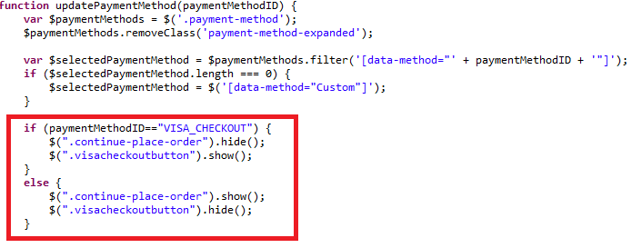

##### paymentmethods.isml

1. Add error condition for Visa Checkout error handling ex:

<isif condition="${pdict.PaypalSetServiceError != null || pdict.VisaCheckoutError != null || pdict.SecureAcceptanceError != null}">

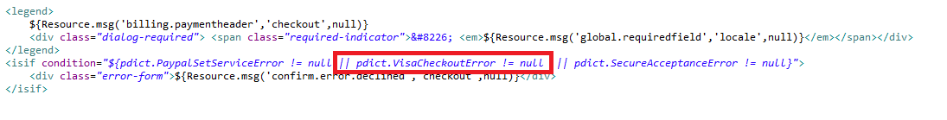

##### billing.isml

* Add class on “continue to place order” button that would be used in billing.js to hide or show button based on payment method selection

|  |
| --- |
| <button class="button-fancy-large secureacceptance continue-place-order" type="button" name="${pdict.CurrentForms.billing.save.htmlName}" value="${Resource.msg('global.continueplaceorder','locale',null)}"><span>${Resource.msg('global.continueplaceorder','locale',null)}</span></button> |

* Include Visa Checkout Button

Add following div section after the form ends

<div class=*"visacheckoutbutton hide"* style="text-align: *center*;">

<isinclude url=*"${URLUtils.url('VisaCheckout-Button')}"*/>

</div>

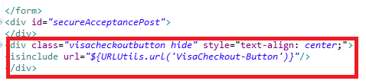

##### cart.isml

1. Include Visa checkout button:

Add following lines before cart-recommendations div

|  |
| --- |
| <!-- BEGIN Visa Checkout code -->  <isif condition="${dw.system.Site.getCurrent().getCustomPreferenceValue('cybVisaButtonOnCart')}">  <isif condition="${pdict.CurrentHttpParameterMap.visacheckout.value}">  <isinclude url="${URLUtils.url('VisaCheckout-Button','visacheckout','pdict.CurrentHttpParameterMap.visacheckout.value')}"/>  <iselse>  <isinclude url="${URLUtils.url('VisaCheckout-Button')}"/>  </isif>  </isif>  <!-- END Visa Checkout code --> |

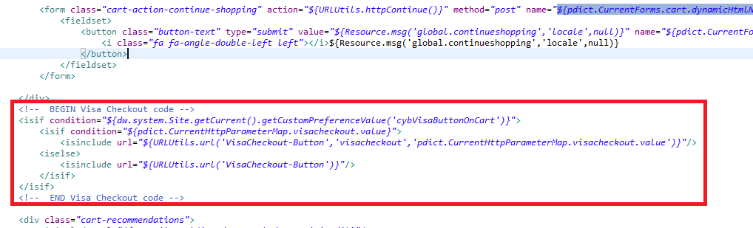

##### minicart.isml

1. Add following line in div having id <div class="mini-cart-totals"> before checkout button

|  |
| --- |
| <!-- BEGIN Visa Checkout code -->  <isif condition="${dw.system.Site.getCurrent().getCustomPreferenceValue('cybVisaButtonOnCart')}">  <isif condition="${empty(pdict.CurrentHttpParameterMap.visacheckout.value) || !pdict.CurrentHttpParameterMap.visacheckout.value}">  <isinclude url="${URLUtils.url('VisaCheckout-Button','buttonsource','minicart')}"/>  <iselse>  <isinclude url="${URLUtils.url('VisaCheckout-Button')}"/>  </isif>  </isif>  <!-- END Visa Checkout code --> |

##### footer_UI.isml

1. Include the template visacheckout/launch.isml at the end of the file.

<iscomment>Visa Checkout launch</iscomment>

<isinclude template="visacheckout/launch.isml" />

##### header.isml

1. In the header section replace mini-cart section with below snippet

<iscomment>INCLUDE: Mini-cart, do not cache</iscomment>

|  |
| --- |
| <div id=*"mini-cart"*>  <isif condition=*"${!empty(pdict.CurrentHttpParameterMap.visacheckout.value) && pdict.CurrentHttpParameterMap.visacheckout.value}"*>  <isinclude url=*"${URLUtils.url('Cart-MiniCart','visacheckout',pdict.CurrentHttpParameterMap.visacheckout.value)}"*/>  <iselse>  <isinclude url=*"${URLUtils.url('Cart-MiniCart')}"*/></isif>  </div> |

##### htmlhead.isml

1. Add following line to prevent visa checkout clickjacking in the end

<iscomment>Visa Checkout clickjacking prevention</iscomment>

<isinclude template="visacheckout/clickjackingPrevent.isml" />

#### Controller - Cart.js

##### Update the Show() method

1. Add following hightlighted line of code to show() function as shown in the snippet:

|  |
| --- |
| **function** show() {  **var** cartForm = app.getForm('cart');  app.getForm('login').invalidate();  cartForm.get('shipments').invalidate();  **var** VisaCheckout = require('int_cybersource_controllers/cartridge/controllers/VisaCheckout');  **var** VInitFormattedString='';  **var** signature='';  **var** result = VisaCheckout.Initialize();  **if** (result.success) {  VInitFormattedString = result.VInitFormattedString;  signature= result.signature;  }  // TO handle the visa checkout click even on cart and billing page from mini cart  session.custom.cyb_CurrentPage = "CybCart";  app.getView('Cart', {  cart: app.getModel('Cart').get(),  RegistrationStatus: **false**,  VInitFormattedString:VInitFormattedString,  Signature:signature  }).render('checkout/cart/cart');  } |

#### Controller - COBilling.js

##### Update start () function to make Visa checkout button non clickable on billing and cart page

|  |
| --- |
| /**  * Updates cart calculation and page information and renders the billing page.  * **@transactional**  * **@param** {module:models/CartModel~CartModel} cart - A CartModel wrapping the current Basket.  * **@param** {object} params - (optional) if passed, added to view properties so they can be accessed in the template.  */  **function** start(cart, params) {  app.getController('COShipping').PrepareShipments();  // TO handle the visa checkout click even on cart and billing page from mini cart  session.custom.cyb_CurrentPage = "CybBilling";  Transaction.wrap(**function** () {  cart.calculate();  });  **var** pageMeta = require('~/cartridge/scripts/meta');  pageMeta.update({  pageTitle: Resource.msg('billing.meta.pagetitle', 'checkout', 'SiteGenesis Checkout')  });  returnToForm(cart, params);  } |

##### Update the returnToForm() method

|  |
| --- |
| **function** returnToForm(cart, params) {  **var** pageMeta = require('~/cartridge/scripts/meta');  // if the payment method is set to gift certificate get the gift certificate code from the form  **if** (!empty(cart.getPaymentInstrument()) && cart.getPaymentInstrument().getPaymentMethod() === PaymentInstrument.METHOD_GIFT_CERTIFICATE) {  app.getForm('billing').copyFrom({  giftCertCode: cart.getPaymentInstrument().getGiftCertificateCode()  });  }    **var** VisaCheckout = require('int_cybersource/cartridge/scripts/helper/VisaCheckoutHelper');  **var** VInitFormattedString='',signature='';  **var** result = VisaCheckout.Initialize(**false**);//no delivery address in lightbox  **if** (result.success) {  VInitFormattedString = result.VInitFormattedString;  signature = result.signature;  }  pageMeta.update({  pageTitle: Resource.msg('billing.meta.pagetitle', 'checkout', 'SiteGenesis Checkout')  });  **if** (params) {  app.getView(require('~/cartridge/scripts/object').extend(params, {  Basket: cart.object,  VInitFormattedString:VInitFormattedString,  Signature:signature,  ContinueURL: URLUtils.https('COBilling-Billing')  })).render('checkout/billing/billing');  } **else** {  app.getView({  Basket: cart.object,  VInitFormattedString:VInitFormattedString,  Signature:signature,  ContinueURL: URLUtils.https('COBilling-Billing')  }).render('checkout/billing/billing');  }  } |

### Secure Acceptance

#### Generic Section

##### JS file – billing.js [compiled to app.js]

##### Update “export.init “function

* Add below code snippet after $('#creditCardList').on('change', function () {

|  |
| --- |
| // Secure Acceptance Redirect or iframe payment method : on selection change of saved credit card  $('.creditCardList').on('change', **function** () {  **var** cardUUID = $(**this**).val();  **if** (!cardUUID) {**return**;}    **var** selectedPaymentMethod = $selectPaymentMethod.find(':checked').val();  populateCreditCardForm(cardUUID,selectedPaymentMethod);  // remove server side error  $('.required.error').removeClass('error');  $('.error-message').remove();  }); |

###### Update “populateCreditCardForm” function

|  |
| --- |
| **function** populateCreditCardForm(cardID,selectedPaymentMethod) {  // load card details  **var** url = util.appendParamToURL(Urls.billingSelectCC, 'creditCardUUID', cardID);  ajax.getJson({  url: url,  callback: **function** (data) {  **if** (!data) {  window.alert(Resources.CC_LOAD_ERROR);  return false;  }  **switch** (selectedPaymentMethod) {  **case** "SA_REDIRECT":  $('.payment-method-expanded .saCCToken .field-wrapper').val(data.selectedCardID); $("#dwfrm_billing_paymentMethods_creditCard_selectedCardID").val(data.selectedCardID);  break;  **case** "SA_IFRAME":  $('.payment-method-expanded .saIframeCCToken .field-wrapper').val(data.selectedCardID); $("#dwfrm_billing_paymentMethods_creditCard_selectedCardID").val(data.selectedCardID);  break;  **case** "CREDIT_CARD":  setCCFields(data);  break;  default:  setCCFields(data);  }  }  });  } |

##### Template – Cart.isml

* Add below error condition just after cart-banner

|  |
| --- |
| <isslot id="cart-banner" description="Banner for Cart page" context="global" />  <isif condition="${pdict.CurrentHttpParameterMap.SecureAcceptanceError != null && !empty(pdict.CurrentHttpParameterMap.SecureAcceptanceError.stringValue)}">  <div class="error-form">${Resource.msg('sa.cart.payment.error.declined','cybersource',null)}</div>  </isif> |

##### Template – Summary.isml

* Replace the PlaceOrderError section with below code

|  |
| --- |
| <isif condition=*"${pdict.CurrentHttpParameterMap.SecureAcceptanceError != null && !empty(pdict.CurrentHttpParameterMap.SecureAcceptanceError.stringValue)}"*>  <div class=*"error-form"*>${Resource.msg('confirm.error.technical','checkout',null)}</div>  <iselseif condition=*"${pdict.PlaceOrderError != null}"*>  <div class=*"error-form"*>${Resource.msg(pdict.PlaceOrderError.code,'checkout',null)}</div>  </isif> |

##### Template – Billing.isml

* Add below error condition just after checkout progress indicator

|  |
| --- |
| <isif condition="${!pdict.CurrentForms.multishipping.entered.value}">  <ischeckoutprogressindicator step="2" multishipping="false" rendershipping="${pdict.Basket.productLineItems.size() == 0 ? 'false' : 'true'}"/>  <iselse/>  <ischeckoutprogressindicator step="3" multishipping="true" rendershipping="${pdict.Basket.productLineItems.size() == 0 ? 'false' : 'true'}"/>  </isif>    <isif condition=*"${pdict.CurrentHttpParameterMap.SecureAcceptanceError != null && !empty(pdict.CurrentHttpParameterMap.SecureAcceptanceError.stringValue)}"*>  <div class=*"error-form"*>${Resource.msg('sa.billing.payment.error.declined','cybersource',null)}</div>  </isif> |

##### Template – paymentmethod.isml

* Add below code snippet to handle secure acceptance error

|  |
| --- |
| <isif condition="${ pdict.VisaCheckoutError != null || pdict.SecureAcceptanceError != null}">  <div class=*"error-form"*>${Resource.msg('confirm.error.declined','checkout',null)}</div>  </isif> |

##### Form – creditcard.xml

* Set the default value of formid="saveCard" to false

|  |
| --- |
| <field formid="saveCard" label="creditcard.savecard" type="boolean" mandatory="false" default-value="false" /> |

* Add more year options as below:

|  |
| --- |
| <option optionid="2022" label="year.2022" value="2022"/>  <option optionid="2023" label="year.2023" value="2023"/>  <option optionid="2024" label="year.2024" value="2024"/>  <option optionid="2025" label="year.2025" value="2025"/>  <option optionid="2026" label="year.2026" value="2026"/>  <option optionid="2027" label="year.2027" value="2027"/>  <option optionid="2028" label="year.2028" value="2028"/>  <option optionid="2029" label="year.2029" value="2029"/>  <option optionid="2030" label="year.2030" value="2030"/>  <option optionid="2031" label="year.2031" value="2031"/>  <option optionid="2032" label="year.2032" value="2032"/>  <option optionid="2033" label="year.2033" value="2033"/>  <option optionid="2034" label="year.2034" value="2034"/>  <option optionid="2035" label="year.2035" value="2035"/>  <option optionid="2036" label="year.2036" value="2036"/>  <option optionid="2037" label="year.2037" value="2037"/> |

##### Resources – form.properties

* Add year values above year year.2022=2022

|  |
| --- |
| year.2037=2037  year.2036=2036  year.2035=2035  year.2034=2034  year.2033=2033  year.2032=2032  year.2031=2031  year.2030=2030  year.2029=2029  year.2028=2028  year.2027=2027  year.2026=2026  year.2025=2025  year.2024=2024  year.2023=2023  year.2022=2022 |

#### Secure Acceptance Redirect Section

* All secure acceptance redirect implementation changes will be inside int_CyberSource and int_CyberSource_controller cartridge

#### Secure Acceptance Iframe Section

##### Controller - COPlaceOrder.js

###### Update “Start” function

* Add below code for new transition returnToPage(if not found in generic section)

|  |
| --- |
| **var** handlePaymentsResult = handlePayments(order);  **if** (handlePaymentsResult.error) {  session.custom.SkipTaxCalculation=**false**;  **return** Transaction.wrap(**function** () {  OrderMgr.failOrder(order);  **return** {  error: **true**,  PlaceOrderError: **new** Status(Status.ERROR, 'confirm.error.declined')  };  });  }**else** **if**(handlePaymentsResult.returnToPage){  app.getView({Order : handlePaymentsResult.order}).render('checkout/summary/summary');  **return** {};  } **else** **if** (handlePaymentsResult.missingPaymentInfo) { |

###### Update “HandlePayments” function

* **Add a new** transition”**returnToPage”** in COPlaceOrder-HandlePayments

|  |
| --- |
| authorizationResult = PaymentProcessor.authorize(order, paymentInstrument);  **if** (authorizationResult.not_supported || authorizationResult.error || authorizationResult.failed) {  **return** {  error: **true**  };  } **else** **if**(authorizationResult.returnToPage){  **return** {returnToPage :**true**, order : order  };  } |

##### Controller - COSummary.js

###### Create new “SubmitOrder” function

Add a new function as below and add the export of the function at the end of file

|  |
| --- |
| **function** submitOrder() {  **var** cart = Cart.get();  **if** (cart) {  submit();  **return**;  } **else** **if** (!empty(session.privacy.order_id)) {  response.addHttpHeader("X-FRAME-OPTIONS","SAMEORIGIN");  **var** Order = app.getModel('Order');  app.getView({  Order : Order.get(session.privacy.order_id).object  }).render('checkout/summary/summary');  **return**;  } **else** {  app.getController('Cart').Show();  **return** {};  }  } |

|  |
| --- |
| exports.SubmitOrder = guard.ensure(['https'], submitOrder); |

##### Template changes

###### Update “summary.isml”

Add below line on top of file

|  |
| --- |
| <isset name="summarypage" value="${true}" scope="page"/> |

* Add script for cybersource constant after <isinclude template="util/modules"/>

|  |
| --- |
| <isinclude template="util/modules"/>  <isscript>  var CybersourceConstants = require('int_cybersource/cartridge/scripts/utils/CybersourceConstants');  </isscript>  <isif condition="${!empty(pdict.Basket)}"> |

* Update this code <isreportcheckout checkoutstep="${5}" checkoutname="${'OrderSummary'}"/> with below code snippet and replace pdice.basket with LinenCtr as highlighted below

|  |
| --- |
| <isif condition=*"${!empty(pdict.Basket)}"*>  <isset name=*"LineCntr"* value=*"${pdict.Basket}"* scope=*"page"*/>  <iselseif condition=*"${!empty(pdict.Order)}"*>  <isset name=*"LineCntr"* value=*"${pdict.Order}"* scope=*"page"*/>  </isif>  <isset name=*"summaryaction"* value=*"${URLUtils.https('COSummary-Submit')}"* scope=*"page"* />  <script src=*"${URLUtils.staticURL('/lib/jquery/jquery-1.11.1.min.js')}"* type=*"text/javascript"*></script>  <isset name=*"paymentMethod"* value=*"${null}"* scope=*"page"*/>  <isif condition=*"${!empty(LineCntr.getPaymentInstruments())}"*>  <isloop items=*"${LineCntr.getPaymentInstruments()}"* var=*"paymentInstr"* status=*"loopstate"*>  <isset name=*"paymentMethod"* value=*"${dw.order.PaymentMgr.getPaymentMethod(paymentInstr.paymentMethod).ID}"* scope=*"page"*/>  <isif condition="${dw.order.PaymentMgr.getPaymentMethod(paymentInstr.paymentMethod).ID==CybersourceConstants.METHOD_SA_IFRAME}">  <isset name=*"summaryaction"* value=*"${URLUtils.https('COSummary-SubmitOrder')}"* scope=*"page"* />  <isbreak/>  </isif>  </isloop>  </isif>  <isif condition=*"${!empty(LineCntr)}"*>  <isreportcheckout checkoutstep=*"${5}"* checkoutname=*"${'OrderSummary'}"*/>  <isif condition=*"${!pdict.CurrentForms.multishipping.entered.value}"*>  <ischeckoutprogressindicator step=*"3"* multishipping=*"false"* rendershipping=*"${LineCntr.productLineItems.size() == 0 ? 'false' : 'true'}"*/>  <iselse/>  <ischeckoutprogressindicator step=*"4"* multishipping=*"true"* rendershipping=*"${LineCntr.productLineItems.size() == 0 ? 'false' : 'true'}"*/>  </isif>  <isif condition=*"${pdict.PlaceOrderError != null}"*>  <div class=*"error-form"*>${Resource.msg(pdict.PlaceOrderError.code,'checkout',null)}</div>  </isif>  </isif> |

* Update the line <isloop items="${pdict.Basket.shipments}" var="shipment" status="shipmentloopstate"> with below code

|  |
| --- |
| <isloop items="${LineCntr.shipments}" var="shipment" status="shipmentloopstate">  <isif condition="${shipment.productLineItems.size() > 0 || shipment.giftCertificateLineItems.size() > 0}">  <isset name="shipmentCount" value="${shipmentCount+1}" scope="page"/>  <isif condition="${LineCntr.shipments.size() > 1}">  <tr class="cart-row">  <td colspan="5">  <div class="shipment-label">${Resource.msgf('multishippingshipments.shipment','checkout',null, shipmentCount)}</div>  </td>  </tr>  </isif> |

* Update pdict.Basket with LineCntr for below line

|  |
| --- |
| <iscomment>RENDER COUPON/ORDER DISCOUNTS</iscomment>  <isloop items="${LineCntr.couponLineItems}" var="couponLineItem" status="cliloopstate"> |

* Update pdict.Basket with LineCntr for below line

|  |
| --- |
| <isloop items="${LineCntr.priceAdjustments}" var="priceAdjustment" status="cliloopstate"> |

* Update pdict.Basket with LineCntr for below line

|  |
| --- |
| <isordertotals p_lineitemctnr="${LineCntr}" p_showshipmentinfo="${false}" p_shipmenteditable="${false}" p_totallabel="${Resource.msg('summary.ordertotal','checkout',null)}"/> |

* Add a condition just above form action and update the form action as below

|  |
| --- |
| <isif condition="${!empty(pdict.Basket)}">  <form action="${summaryaction}" method="post" class="submit-order">  <fieldset>  <div class="form-row">  <a class="back-to-cart" href="${URLUtils.url('Cart-Show')}">  <isprint value="${Resource.msg('summary.editcart','checkout',null)}" encoding="off" /></a>  <button class="button-fancy-large" type="submit" name="submit" value="${Resource.msg('global.submitorder','locale',null)}">  ${Resource.msg('global.submitorder','locale',null)}  </button>  </div>  </fieldset>  </form>  </isif> |

* Add below condition at the end of file and just above </isdecorate>

|  |
| --- |
| <isif condition="${paymentMethod != null && paymentMethod==CybersourceConstants.METHOD_SA_IFRAME}"><isinclude template="custom/secureAcceptanceIframeSummmary"/>  </isif>  </isdecorate> |

###### Update “miniBillingInfo.isml”

Replace the line

<isset name=*"billingAddress"* value=*"${pdict.Basket.billingAddress}"* scope=*"page"*/>

<isset name=*"paymentInstruments"* value=*"${pdict.Basket.paymentInstruments}"* scope=*"page"*/> with the code below

|  |
| --- |
| <isif condition="${!empty(pdict.Basket)}"><isset name="lineCtnr" value="${pdict.Basket}" scope="page"/>  <isset name="billingAddress" value="${lineCtnr.billingAddress}" scope="page"/>  <isset name="paymentInstruments" value="${lineCtnr.paymentInstruments}" scope="page"/>  <iselseif condition="${!empty(pdict.Order)}">  <isset name="lineCtnr" value="${pdict.Order}" scope="page"/>  <isset name="billingAddress" value="${pdict.Order.billingAddress}" scope="page"/>  <isset name="paymentInstruments" value="${pdict.Order.paymentInstruments}" scope="page"/>  </isif>  <isif condition="${!empty(billingAddress)}"> |

* Replace <a tag in billingAddress if condition with the line below

|  |
| --- |
| <div class="mini-billing-address order-component-block">  <h3 class="section-header">  <isif condition="${!empty(pdict.Basket)}"><a href="${URLUtils.https('COBilling-Start')}" class="section-header-note">${Resource.msg('global.edit','locale',null)}</a></isif>  ${Resource.msg('minibillinginfo.billingaddress','checkout',null)}  </h3>  <div class="details">  <isminicheckout_address p_address="${billingAddress}"/>  </div>  </div> |

* Replace <a tag in paymentInstruments if condition with the line below

|  |
| --- |
| <isloop items=*"${paymentInstruments}"* var=*"paymentInstr"* status=*"loopstate"*>          <div class=*"mini-payment-instrument  order-component-block <isif condition="*${loopstate.first}"> first <iselseif condition=*"${loopstate.last}"*> last</isif>">  <h3 class=*"section-header"*>                                    <isif condition=*"${!empty(pdict.Basket)}"*><a href=*"${URLUtils.https('COBilling-Start')}"*  class=*"section-header-note"*>${Resource.msg('global.edit','locale',null)}</a></isif>                                           <isif condition=*"${loopstate.first}"*><span>${Resource.msg('minibillinginfo.paymentmethod','checkout',null)}</span></isif>              </h3> |

###### Update “miniSummary.isml”

* Add below code snippet just above this line <isif condition="${!empty(pdict.checkoutstep)}">

|  |
| --- |
| <isif condition="${!empty(pdict.Basket)}">  <isset name="lineCtnr" value="${pdict.Basket}" scope="page"/>  <iselseif condition="${!empty(pdict.Order)}">  <isset name="lineCtnr" value="${pdict.Order}" scope="page"/>  </isif>  <isif condition="${!empty(pdict.checkoutstep)}"> |

* Replace the line with below line <isif condition="${checkoutstep <= 5}">

|  |
| --- |
| <isif condition="${checkoutstep <= 6}"> |

* Replace pdict.Basket with lineCtnr at below places

|  |
| --- |
| <isif condition="${lineCtnr.productLineItems.size() == 0 && lineCtnr.giftCertificateLineItems.size() == 1}">  <isset name="editUrl" value="${URLUtils.url('GiftCert-Edit','GiftCertificateLineItemID', lineCtnr.giftCertificateLineItems[0].UUID)}" scope="page"/>  </isif> |

* Replace the line with below ${Resource.msg('summary.title','checkout',null)} <a class="section-header-note" href="${editUrl}">${Resource.msg('global.edit','locale',null)}</a>

|  |
| --- |
| ${Resource.msg('summary.title','checkout',null)} <isif condition="${!empty(pdict.Basket)}"><a class="section-header-note" href="${editUrl}">${Resource.msg('global.edit','locale',null)}</a></isif> |

* Update the DIV “checkout-mini-cart” with below code

|  |
| --- |
| <div class="checkout-mini-cart">  <isif condition="${checkoutstep != 5 && checkoutstep != 6}">  <isminilineitems p_lineitemctnr="${lineCtnr}"/>  </isif>  </div> |

* Update the DIV “checkout-order-totals” with below code

|  |
| --- |
| <div class=" checkout-order-totals">  <isif condition="${checkoutstep == 6}">  <isordertotals p_lineitemctnr="${lineCtnr}" p_showshipmentinfo="${true}" p_shipmenteditable="${false}" p_totallabel="${Resource.msg('global.ordertotal','locale',null)}"/>  <iselseif condition="${checkoutstep > 3}">  <isordertotals p_lineitemctnr="${lineCtnr}" p_showshipmentinfo="${true}" p_shipmenteditable="${true}" p_totallabel="${Resource.msg('global.ordertotal','locale',null)}"/>  <iselse/>  <isordertotals p_lineitemctnr="${lineCtnr}" p_showshipmentinfo="${false}" p_shipmenteditable="${false}" p_totallabel="${Resource.msg('global.estimatedtotal','locale',null)}"/>  </isif>  </div> |

###### Update “minshipments.isml”

* Replace this line <isset name="Shipments" value="${pdict.Basket.shipments}" scope="page"/> with below code snippet

|  |
| --- |
| <isif condition="${!empty(pdict.Basket)}">  <isset name="lineCtnr" value="${pdict.Basket}" scope="page"/>  <isset name="Shipments" value="${lineCtnr.shipments}" scope="page"/>  <iselseif condition="${!empty(pdict.Order)}">  <isset name="lineCtnr" value="${pdict.Order}" scope="page"/>  <isset name="Shipments" value="${pdict.Order.shipments}" scope="page"/>  </isif> |

* Replace pdict.Basket with lineCtnr at below places

|  |
| --- |
| <isif condition="${shipment.productLineItems.length <= 0 || shipment.custom.shipmentType == null && shipment.UUID==lineCtnr.defaultShipment.UUID && !empty(shipment.shippingAddress) && empty(shipment.shippingAddress.address1)}"> |
| <isif condition="${Shipments.size() > 1 && lineCtnr.productLineItems.size() > 0}"><div class="name">${Resource.msgf('multishippingshipments.shipment','checkout',null, shipmentCount)}</div></isif> |

* Replace the line with below <a href="${editUrl}" class="section-header-note">${Resource.msg('global.edit','locale',null)}</a> twice in a file

|  |
| --- |
| <iselseif condition="${shipment.custom.shipmentType == 'instore'}"/>  <isset name="editUrl" value="${URLUtils.https('Cart-Show')}" scope="page"/>  <isif condition="${!empty(pdict.Basket)}"><a href="${editUrl}" class="section-header-note">${Resource.msg('global.edit','locale',null)}</a></isif>  ${Resource.msg('cart.store.instorepickup','checkout',null)}  <iselseif condition="${shipment.shippingAddress != null && lineCtnr.productLineItems.size() > 0}"/>  <isif condition="${!empty(pdict.Basket)}"><a href="${editUrl}" class="section-header-note">${Resource.msg('global.edit','locale',null)}</a></isif>  ${Resource.msg('minishipments.shippingaddress','checkout',null)}  </isif> |

* Replace pdict.Basket with lineCtnr at below line

|  |
| --- |
| <iselseif condition="${shipment.shippingAddress != null && lineCtnr.productLineItems.size() > 0}"> |

###### Update “ReportCheckout.isml”

* Add a condition after this <isset name="checkoutname" value="${pdict.checkoutname}" scope="page"/> with below code snippet

|  |
| --- |
| <isset name="LineCntr" value="${pdict.Basket}" scope="page"/>  <isif condition="${!empty(pdict.Basket)}">  <isset name="LineCntr" value="${pdict.Basket}" scope="page"/>  <iselseif condition="${!empty(pdict.Order)}">  <isset name="LineCntr" value="${pdict.Order}" scope="page"/>  </isif> |

* Replace pdict.Basket with LineCntr twice in file along with null check

|  |
| --- |
| 'BasketID', null != LineCntr ? LineCntr.UUID:null, |

##### Core - scss changes

###### Update “_checkout.scss”

* Add below code snippet at the end of file

|  |
| --- |
| .SecureAcceptance_IFRAME iframe{  height**:**600px !important**;**  **}**  @media screen and **(** max-width**:**1024px **){**  .SecureAcceptance_IFRAME iframe**{**  height**:**650px !important**;**  **}**  **}**  @media screen and **(** max-width**:**767px **){**  .SecureAcceptance_IFRAME iframe**{**  height**:**670px !important**;**  **}**  **}** |

#### Secure Acceptance Silent Post Section

##### Template - billing.isml

Add a a div for secure acceptance silent post after the end of </form> tag

|  |
| --- |
| </form>  <div id=*"secureAcceptancePost"*>  </div> |

Add a “secureacceptance” class inside button and specify type as”button”as below

|  |
| --- |
| <div class=*"form-row form-row-button"*>  <button class=*"button-fancy-large secureacceptance continue-place-order"* type=*"button"* name=*"${pdict.CurrentForms.billing.save.htmlName}"* value=*"${Resource.msg('global.continueplaceorder','locale',null)}"*><span>${Resource.msg('global.continueplaceorder','locale',null)}</span></button>  </div> |

##### Core – footer_UI.isml

Include script jquery.payment.js of cybersource cartridge

|  |
| --- |
| <script src="${URLUtils.staticURL('/lib/jquery/jquery.validate.min.js')}" type="text/javascript"></script>  <script src="${URLUtils.staticURL('/lib/jquery/jquery.payment.js')}" type="text/javascript"></script> |

##### Core – Resource.ds

* Add two new Resource in ResourceHelper.getResources

|  |
| --- |
| QUICK_VIEW_POPUP : Resource.msg('product.quickview.popup', 'product', null),  INVALID_SERVICE : Resource.msg('checkout.getsignature.service.problem', 'checkout', null),  INVALID_CREDITCARD : Resource.msg('checkout.invalid.credit.card.info', 'checkout', null) |

* Add below line under ResourceHelper.getUrls

|  |
| --- |
| ,  silentpost : URLUtils.https('SECURE_ACCEPTANCE-GetRequestDataForSilentPost').toString() |

##### Core - billing.js

###### Create new “secureacceptance” on Click function

Create a new secure acceptance silent post function to handle credit card information using Ajax call above this function $couponCode.on('keydown', function (e) {

|  |
| --- |
| $('.secureacceptance').on('click', **function** (e) {    **var** $selectPaymentMethod = $('.payment-method-options');  **var** selectedPaymentMethod = $selectPaymentMethod.find(':checked').val();  **if** ('SA_SILENTPOST' == selectedPaymentMethod) {  **var** $checkoutForm = $('.checkout-billing');  **var** ccnumber = $($checkoutForm).find('input[name$="_creditCard_number"]').val();  **var** cvn = $($checkoutForm).find('input[name$="_creditCard_cvn"]').val();  **var** month = $('.payment-method-expanded .month select').val();  **var** expyear = $('.payment-method-expanded .year select').val();  **var** dwcctype = $('.payment-method-expanded .cctype select').val();  var savecc = $($checkoutForm).find('input[name$="_creditCard_saveCard"]').is(':checked');  **var** customerEmail = $("#dwfrm_billing_billingAddress_email_emailAddress").val();  **var** cardmap= {'Visa': '001','Amex': '003','MasterCard': '002','Discover': '004','Maestro':'042'};  **if**(month.length == 1) {  month = "0"+month;  }  **var** cctype = cardmap[dwcctype];    **var** firstname = encodeRequestFieldValue($($checkoutForm).find('input[name$="_addressFields_firstName"]').val());  **var** lastname = encodeRequestFieldValue($($checkoutForm).find('input[name$="_addressFields_lastName"]').val());  **var** address1 = encodeRequestFieldValue($($checkoutForm).find('input[name$="_addressFields_address1"]').val());  **var** address2 = encodeRequestFieldValue($($checkoutForm).find('input[name$="_addressFields_address2"]').val());  **var** city = encodeRequestFieldValue($($checkoutForm).find('input[name$="_addressFields_city"]').val());  **var** zipcode = encodeRequestFieldValue($($checkoutForm).find('input[name$="_addressFields_postal"]').val());  **var** country = encodeRequestFieldValue($($checkoutForm).find('select[name$="_addressFields_country"]').val());  **var** state = $($checkoutForm).find('select[name$="_addressFields_states_state"]').val();  **if** (state===**undefined**) {  state = $($checkoutForm).find('input[name$="_addressFields_states_state"]').val();  }  state = encodeRequestFieldValue(state);  **var** phoneno = encodeRequestFieldValue($($checkoutForm).find('input[name$="_addressFields_phone"]').val());  **var** cctoken = encodeRequestFieldValue($('[data-method="CREDIT_CARD"]').find('[name$="creditCard_selectedCardID"]').val());    **var** validCardType = dwcctype.toLowerCase();  **var** validCardNumber = $.payment.validateCardNumber(ccnumber);  **var** validCardCvv= $.payment.validateCardCVC(cvn,validCardType);  **var** validCardExp = $.payment.validateCardExpiry(month, expyear);    **if**(cctoken) {  validCardNumber = **true**;  }    $($checkoutForm).find('input[name$="_creditCard_number"]').val("");  $($checkoutForm).find('input[name$="_creditCard_cvn"]').val("");  $($checkoutForm).find('input[name$="_creditCard_expiration_month"]').val("");  $($checkoutForm).find('input[name$="_creditCard_expiration_year"]').val("");  $($checkoutForm).find('input[name$="_creditCard_type"]').val("");    **if**(validCardCvv && validCardExp && validCardNumber) {  **var** data = {  custemail : customerEmail,  savecc : savecc,  firstname : firstname,  lastname : lastname,  address1 : address1,  address2 : address2,  city : city,  zipcode : zipcode,  country : country,  state : state,  phone : phoneno,  cctoken : cctoken,  format : 'ajax'  };  $.ajax({  url: Urls.silentpost,  type: "POST",  data: data,  success: **function**(xhr,data) {  **if**(xhr) {  **if**(xhr.error == **true**) { $("#saspCardError").html(xhr.errorMsg);  $("#saspCardError").addClass('error');  }  **else** { $("#secureAcceptancePost").html(xhr);  $("#card_expiry_date").val(month +'-'+expyear); $("#card_type").val(cctype);  $("#card_cvn").val(cvn); **if**(cctoken == **null** || cctoken == '') {  $('#silentPostFetchToken').append('<input type="hidden" id="card_number" name="card_number" />'); $("#card_number").val(ccnumber);  } $("#silentPostFetchToken").submit();  }  }  **else** {  $("#saspCardError").html(Resources.INVALID_SERVICE);  $("#saspCardError").addClass('error');  }  },  error: **function** () { $("#saspCardError").html(Resources.INVALID_SERVICE).addClass('error');  }  });  }  **else**{  $("#saspCardError").html(Resources.INVALID_CREDITCARD);  $("#saspCardError").addClass('error');    **return** **false**;  }  }  **else**{  $('.secureacceptance').prop("type", "submit").submit();  **return** **true**;  }  }); |

###### Create new “encodeRequestFieldValue” function

Create a new function to encode input field value below setCCFields :

|  |
| --- |
| /**  * **@function**  * **@description** function to convert html tag to lt or gt;  * **@param** {fieldValue} value of the field  */  **function** encodeRequestFieldValue(fieldValue) {    **return** fieldValue.replace(/</g, "&lt;").replace(/>/g, "&gt;")  } |

###### Update “updatePaymentMethod “function

* Update the function:

|  |
| --- |
| **function** updatePaymentMethod(paymentMethodID) {  **var** $paymentMethods = $('.payment-method');  $paymentMethods.removeClass('payment-method-expanded');  **var** dataMethod = paymentMethodID;  **if** (paymentMethodID=='SA_SILENTPOST') {  dataMethod = 'CREDIT_CARD';  }  **var** $selectedPaymentMethod = $paymentMethods.filter('[data-method="' + dataMethod + '"]');  **if** ($selectedPaymentMethod.length === 0) {  $selectedPaymentMethod = $('[data-method="Custom"]');  }  **if** (paymentMethodID=="CREDIT_CARD" || paymentMethodID=="SA_SILENTPOST") {  $(".spsavecard").show();  } **else** **if** ((paymentMethodID=="SA_REDIRECT" || paymentMethodID=="SA_IFRAME") && SitePreferences.TOKENIZATION_ENABLED) {  $(".spsavecard").show();  }  else {  $(".spsavecard").hide();  } |

### Device Fingerprint

The device fingerprint enables CyberSource to detect fraud/spam more efficient.  
The device fingerprint can be used as an addition of the Credit Card Payment, it is not an independent service.

#### How does it work?

During/before checkout three (invisible) ‘beacons’ at the checkout page (a JavaScript, an image and a flash object) would collect and transmit several client-specific parameters to CyberSource partner.

Those beacons contain the session Id.

With the Credit Card Payment, this session Id is transmitted again and CyberSource is able to combine the data for advanced fraud detection.

#### Setup:

(Prerequisites: CyberSource cartridge is already installed).

1. Enable the device fingerprint at the Site Preferences of CyberSource and set the Organization ID (provided by CyberSource). The Merchant ID should be set already, anyway.
2. Include following snippet i.e. at the billing.isml page (Recommended: at bottom of page to have no visual impacts)

<isifcondition=*”${dw.system.Site.getCurrent().getCustomPreferenceValue(‘CsDeviceFingerprintEnabled’)}”*>

<isincludeurl=*”${URLUtils.url(‘Cybersource-IncludeDigitalFingerprint’)}”*/>

</isif>

Do a checkout with Credit Card payment. After this checkout, at the CyberSource Business Manager you will see (at the Transaction Manager):

*Device Fingerprint: submitted*

#### Hints for the CsDeviceFingerprintRedirectionType:

To get improved deviceFingerprint results, Cybersource recommends redirecting the included code (loading a image, a flash and a javascript) pointing to the CsJetmetrixLocation, to a local domain.

There are three possible settings for this redirection: ‘none’, static’ and dynamic.

No redirection, the beacons will be loaded direct from the CsJetmetrixLocation (i.e. https://h.online-metrix.net)

*Static* The beacons are included with aemandware controller call. The controller call will redirect to the CsJetmetrixLocation.

Dynamic If set to dynamic, you have to specify a mapping rule at SiteUrls->Static Mappings.

All URLs matching the pattern will be redirected by the Demandware Server.

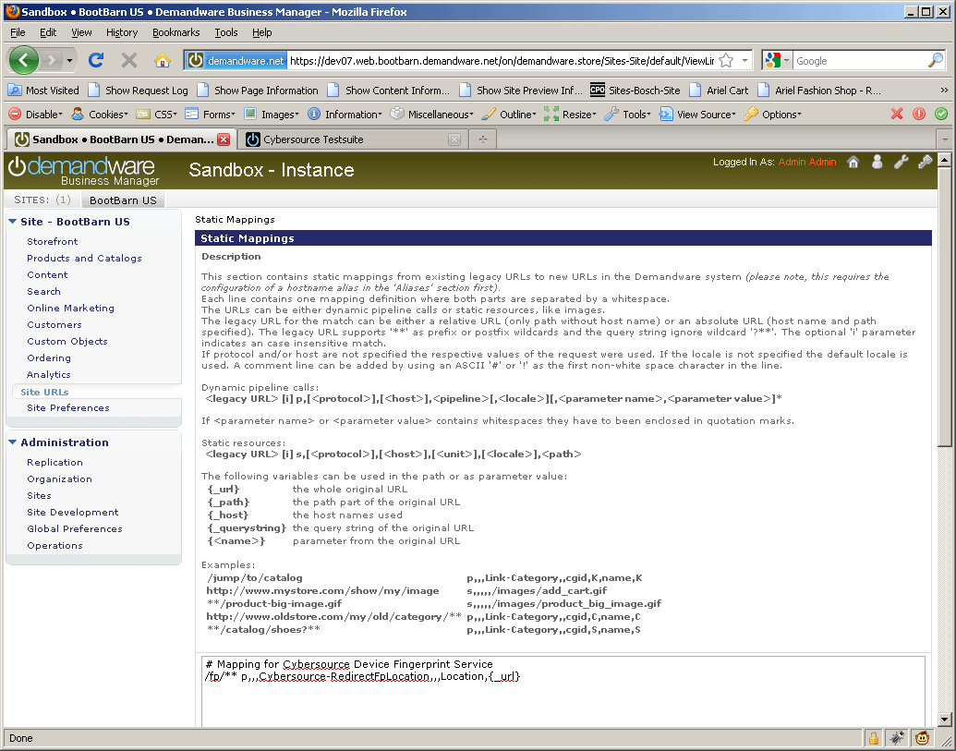

Example for a matching mapping rule for the device fingerprint redirection

Make an Alias entry in Business manager to execute Device finger print with “ Dynamic” redirection Type

Go to Site > Site URLs > Aliases and add an Alias for your domain like below:

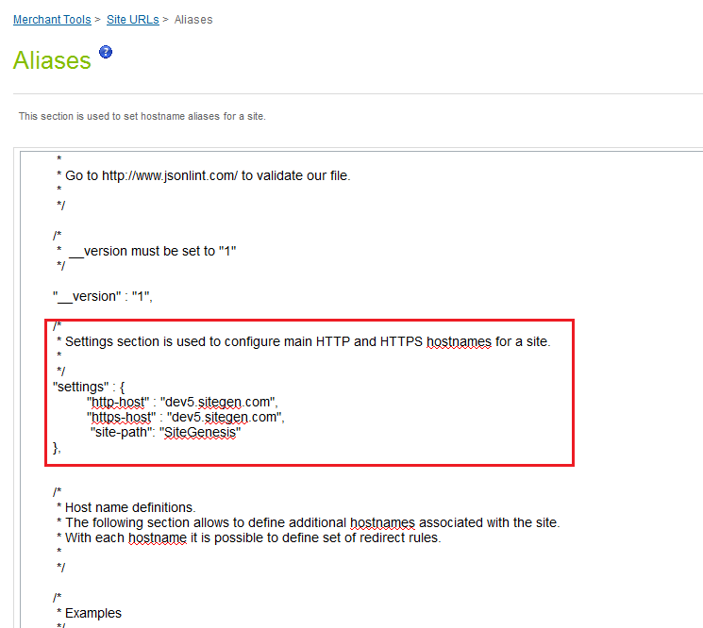

## Site Configuration

### Configure Payment Processor

#### Steps to Create payment processor

Go to Site -> Ordering -> Payment Processors; add a new payment processor with ID and description as given in below table

|  |  |
| --- | --- |
| Processor ID | Description |
| [CYBERSOURCE_ALIPAY](https://cybersource02.tech-prtnr-na02.dw.demandware.net/on/demandware.store/Sites-Site/default/ViewPaymentMethod_52-Show?PaymentMethodUUID=2e465f83282638559e5b5d8909&ChannelID=0529909f885a5606e75e831d7c) | [CYBERSOURCE_ALIPAY](https://cybersource02.tech-prtnr-na02.dw.demandware.net/on/demandware.store/Sites-Site/default/ViewPaymentMethod_52-Show?PaymentMethodUUID=2e465f83282638559e5b5d8909&ChannelID=0529909f885a5606e75e831d7c) (test and production systems). |
| [CYBERSOURCE_CREDIT](https://cybersource02.tech-prtnr-na02.dw.demandware.net/on/demandware.store/Sites-Site/default/ViewPaymentMethod_52-Show?PaymentMethodUUID=d957151d6c54ebbe0d99533b91&ChannelID=0529909f885a5606e75e831d7c) | Cybersource online credit card authorization and visa checkout (test and production systems). |

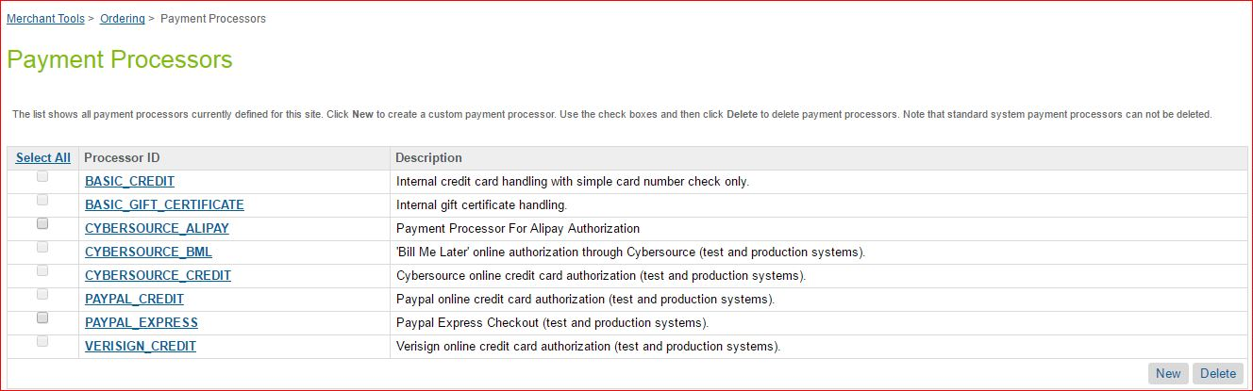

### Import Meta Data

Import following site configuration meta-data through Business Manager:

To import the following site configuration Go to Administration -> Site Development -> Import & Export -> upload the below mentioned files and import the configuration.

* /int_cybersource/configuration/ Cybersource-metadata.xml – sets all the required meta configurations of system defined and custom defined
* /int_cybersource/configuration/ Cybersource_custom-objecttype-definitions.xml – sets all custom attributes for Cybersource

### Import Payment Methods

To import the following site payment methods Go to Site > Ordering > Import & Export-> upload the below mentioned file and import the configuration in to Payment Methods.

* /int_cybersource/configuration/Cybersource_Payment_Methods.xml
* Mechant can enable/disable any of the payment method listed below:

|  |  |
| --- | --- |
| **Payment Method ID** | **Payment Method Name** |
| ALIPAY | Alipay |
| CREDIT_CARD | Credit Card |
| DW_APPLE_PAY | Apple Pay |
| SA_IFRAME | Credit Card - Secure Acceptance Web/Mobile (Iframe) |
| SA_REDIRECT | Credit Card - Secure Acceptance Web/Mobile (Redirect) |
| SA_SILENTPOST | Credit Card - Secure Acceptance Silent Order POST |
| VISA_CHECKOUT | Visa Checkout |

### Configure Services

To import the following Service configuration Go to Administration > Operations > Import & Export-> upload the below mentioned file and import the configuration under services

* /int_cybersource/configuration/Cybersource-Services.xml – add new Service for cybersource integration

After import above file ensure to update credentials as per cybersource merchant account appropriately in BM.

The following Business Manager Screenshot depicts the import / Export functionality:

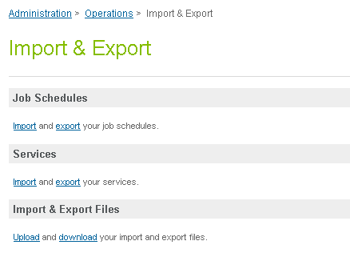

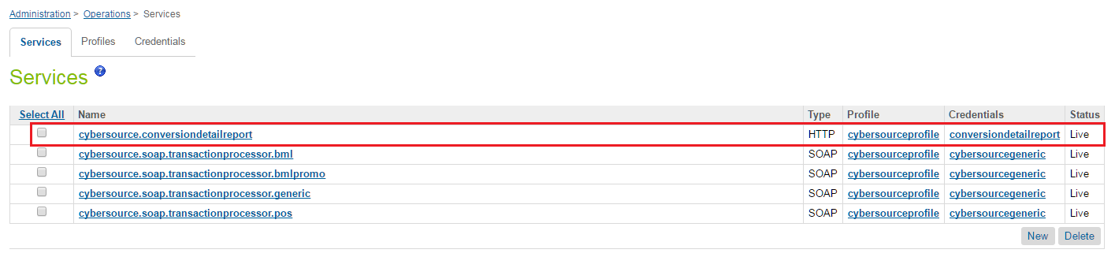

* The below Cybersource Services created with single profile and credential
  1. Cybersource.soap.transactionprocessor.generic
  2. Cybersource.soap.transactionprocessor.pos
  3. Cybersource.conversiondetailreport

The profile name is cybersourceprofile, the merchant can create new profile if they require separate profile settings for each service stated above.

Similarly, merchant can create or update existing credential settings for each service stated above.

There is Cyber Source detailed report service created in DemandWare with below separate Credentials as follows:

1. URL: Specify below report location along with the requested parameter ,the parameter values are replaced at runtime by the JOB code
   * Test environment URL is “https://ebctest.cybersource.com/ebctest/ConversionDetailReportRequest.do?merchantID={merchantID}&username={username}&password={password}&startDate={startDate}&startTime={startTime}&endDate={endDate}&endTime={endTime} "
   * Production environment URL is "https://ebc.cybersource.com/ebctest/ConversionDetailReportRequest.do?merchantID={merchantID}&username={username}&password={password}&startDate={startDate}&startTime={startTime}&endDate={endDate}&endTime={endTime} "
2. User: Merchant specific username [Represents user having report downloader role in cybersource console]
3. Password: Merchant specific password

* Modify the merchant name, timeout details in profile. Also merchant can configure different profiles for different cybersource services depending on need of the project.

Refer below:

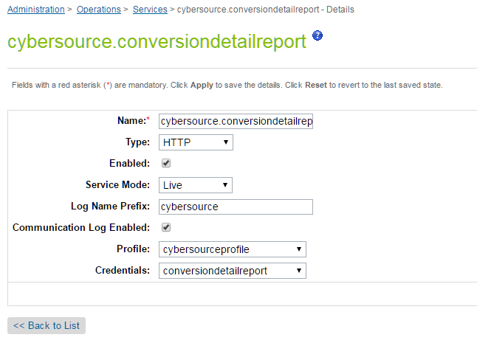

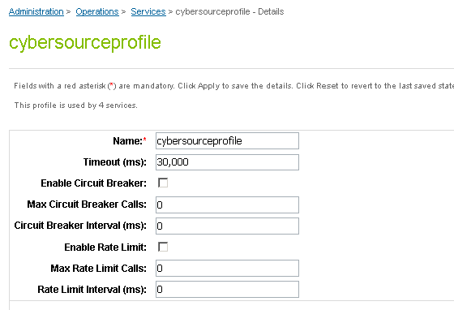

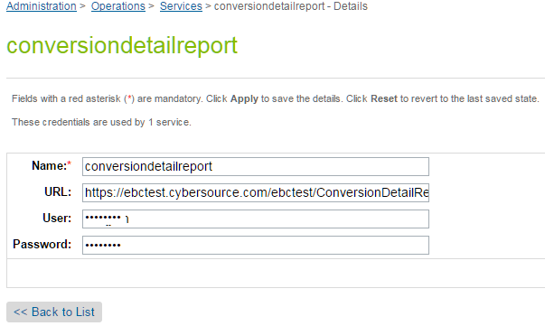

### Configure Site Preferences

#### CyberSource site preference

##### Site Preferences Attribute

|  |  |
| --- | --- |
| Site Preferences | Description |
| CyberSource Merchant Id(CsMerchantId) | CyberSource Merchant ID |
| CyberSource Merchant Key(CsSecurityKey) | CyberSource Security Key |
| CyberSourceEndpoint(CsEndpoint) | CyberSource Web service End points: Test https://ics2wstesta.ic3.com/commerce/1.x/transactionProcessorProdhttps://ics2wsa.ic3.com/commerce/1.x/transactionProcessor |
| CyberSourceShipFromCity(CsShipFromCity) | Ship to data if fixed for the site |
| CyberSourceShipFromStateCode(CsShipFromStateC)ode | Ship to data if fixed for the site |
| CyberSourceShipFromZipCode(CsShipFromZipCode) | Ship to data if fixed for the site |
| CyberSourceShipFrom Country Code(CsShipFromCountryCode) | Ship to data if fixed for the site |
| CyberSource Ignore AVS Result(CsAvsIgnoreResult) | AVS ignore results |
| CyberSource AVS Decline Flags(CsAvsDeclineFlags) |  |
| Cybersource – On Delivery Address Verification Failure(CsDavOnAddressVerificationFailure) |  |
| Cybersource – Enable Delivery Address Verification(CsDavEnable) | This will enable Delivery Address Verification, to help minimize risk of undeliverable or returns orders, because of user data entry errors. |
| CyberSource Merchant ID(CsPaMerchantId) | Payer Auth merchant ID |
| CyberSource Merchant Password(CsPaMerchantPassword) | Payer Auth Merchant Key |
| CyberSource Merchant Name(CsPaMerchantName) | Name |
| CyberSource Purchase Order Acceptance City(CsPoaCity) | CyberSource purchase order acceptance data – used by Tax |
| CyberSource Purchase Order Acceptance State Code(CsPoaStateCode) | CyberSource purchase order acceptance data – used by Tax |
| CyberSource Purchase Order Acceptance Zip Code(CsPoaZipCode) | CyberSource purchase order acceptance data – used by Tax |
| CyberSource Purchase Order Acceptance Country Code(CsPoaCountryCode) | CyberSource purchase order acceptance data – used by Tax |
| CyberSource Purchase Order Origin City(CsPooCity) | CyberSource purchase order origin data – used by Tax |
| CyberSource Purchase Order Origin StateCode(CsPooStateCode) | CyberSource purchase order origin data – used by Tax |
| CyberSource Purchase Order Origin ZipCode(CsPooZipCode) | CyberSource purchase order origin data – used by Tax |
| CyberSource Purchase Order Origin Country Code(CsPooCountryCode) | CyberSource purchase order origin data – used by Tax |
| CyberSource Nexus States List(CsNexus) | CyberSource nexus state list |
| CyberSource No Nexus States List(CsNoNexus) | CyberSource no nexus state list |
| Disable logging of Cybersource traces(CsDebugCybersource) | To enable/disable debugging |
| Cybersource Device Fingeprintenabled(CsDeviceFingerprintEnabled) | To enable / disable the device fingerprint for advanced fraud detection |
| JetmetrixLocation(CsJetmetrixLocation) | Location of device fingerprint service |
| CsDeviceFingerprintOrgId(CsDeviceFingerprintOrgId) | Id of DeviceFingerprintOrgId |
| Device Fingerprint Redirection(CsDeviceFingerprintRedirectionType) | None,static or dynamic for type of redirection. |
| Cybersource – Enable Tokenization(CsTokenizationEnable) | To enable/disable tokenization call in CC Authorization |
| CyberSource Save Proof.xml(CsPaEnableProofXML) | To enable/disable saving of proof.xml in order object |
| Alipay Payment Type(apPaymentType) | Alipay Payment Type for Domestic as well as International Payment |
| Test Reconciliation ID for Alipay(apTestReconciliationID) | Test Reconciliation ID for Alipay to test initiate and check status services. |
| Decision Manager Enable for Card (csCardDecisionManagerEnable) | Setting to enable/disable decision manager for Credit Card authorization |
| CyberSource correct shipping state (CsCorrectShipState) | Default false, whether expect cybersource to correct the shipping state |
| CyberSource Default Product Tax Code (Tax) (CsDefaultProductTaxCode) | Default 5310 Represent default producttaxcodeif not specified |
| CyberSource Save ParesStatus (PA) (CsPaSaveParesStatus) | Default False Save ParesStatus received as response from Pa Authenticate request and send it as param in ccAuth request call. This field should be enabled after verifying cybersource merchant account settings. |
| Master Card Auth Indicator (csMasterCardAuthIndicator) | Default NonePreauthorization: 0 passed in request Final authorization: 1 passed in request Undefined authorization:omit authIndicator field from the request message |
| CsDeveloperID | Merchant developer Id , mandatory for Cybersource configuration (max limit- String 8 char) |

##### Site preference data

Update CyberSource site preference through Business Manager >StoreFront Site> Site Preferences > Custom Preferences.

The screen shot below depicts the site preferences configuration:

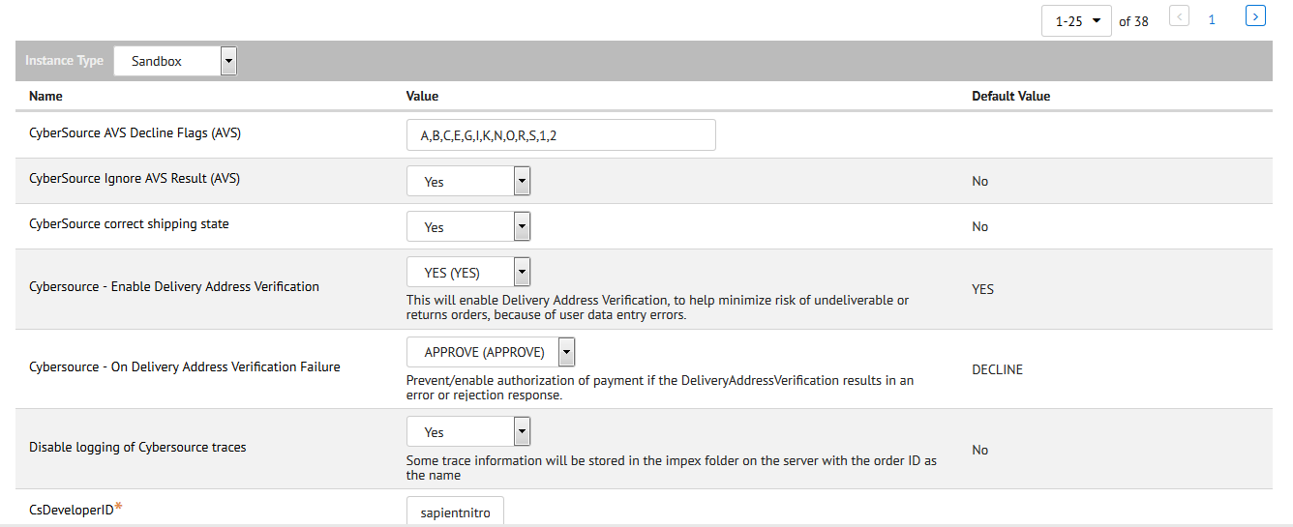

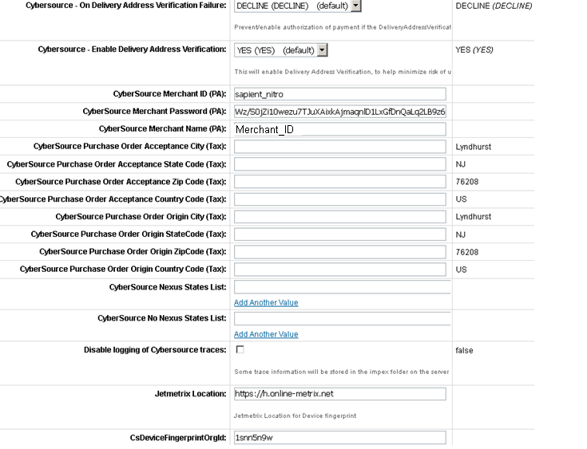

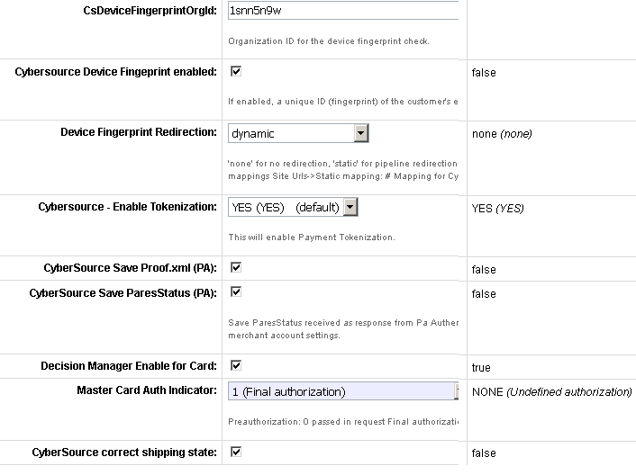

#### Alipay Site Preference

Verify Alipay Site Preferences in already existing custom preferences group “Cybersource”.

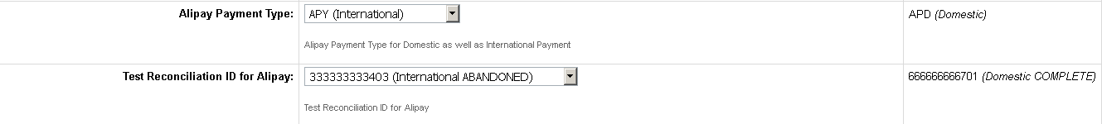

#### Configure Custom Objects for Retail POS

Two custom objects have been added for POS transactions. Ensure to populate these custom objects with merchant specific data. Below are screenshots of sample custom object entry for both custom objects:

* 1. POS_MerchantIDs

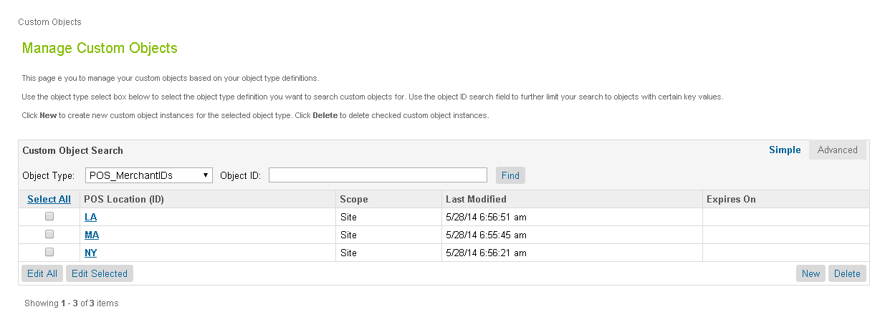

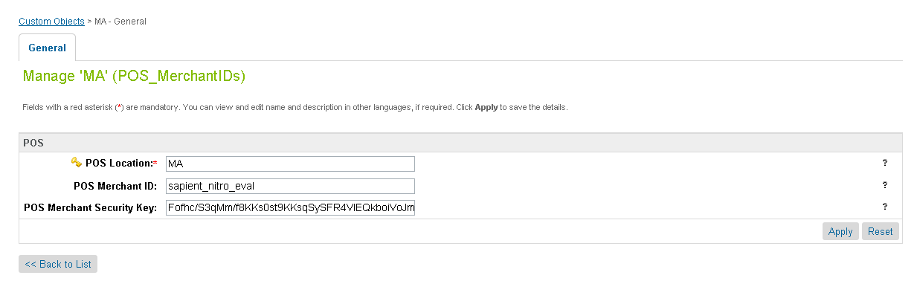

* 1. POS_TerminalMapping

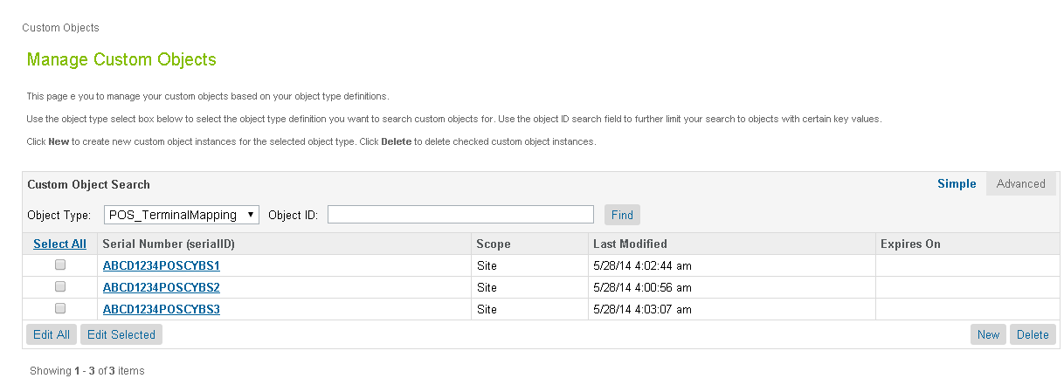

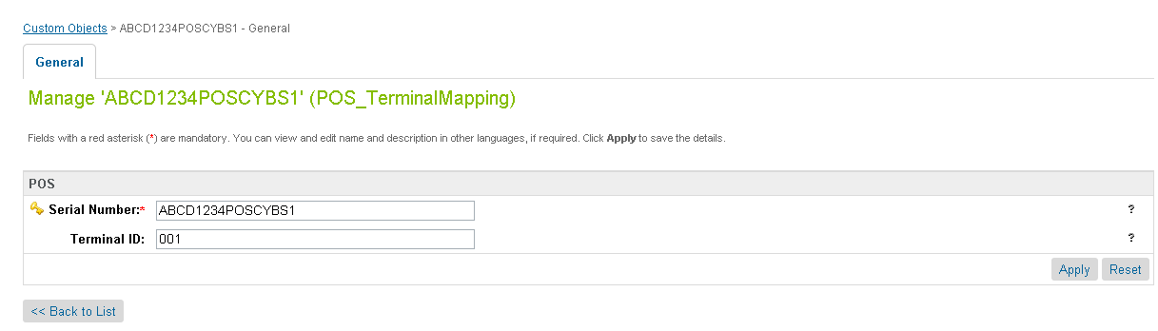

#### Visa Checkout site preference

##### Site Preferences Attribute

Below is the list of attributes added in CyberSource site preference?

* Use the sdk.js JavaScript library to control the operation of Visa Checkout [Field name: **cybVisaSdkJsLibrary**]

|  |  |
| --- | --- |
| **Environment** | **Possible values** |
| Sandbox | <https://sandbox-assets.secure.checkout.visa.com/checkout-widget/resources/js/integration/v1/sdk.js> |
| LIVE | <https://assets.secure.checkout.visa.com/checkout-widget/resources/js/integration/v1/sdk.js> |

* Use the v-button img class to render a Visa Checkout button that a consumer clicks to initiate a payment [Field name: **cybVisaButtonImgUrl**]

|  |  |
| --- | --- |
| **Environment** | **Possible values** |
| Sandbox | <https://sandbox.secure.checkout.visa.com/wallet-services-web/xo/button.png> |
| LIVE | <https://secure.checkout.visa.com/wallet-services-web/xo/button.png> |

* Use below configuration fields for VISA checkout setup and must be different for sandbox and production based on merchant accounts

|  |  |
| --- | --- |
| **Field** | **Description** |
| cybVisaExternalProfileId | Use profile's name, created externally by a merchant whom Visa Checkout uses to populate settings, such as accepted card brands and shipping regions. The properties set in this profile override properties in the merchant's current profile. (Alphanumeric; maximum 50 characters) |
| cybVisaAPIKey | The Visa Checkout account API key specified in cybersource business center (Alphanumeric; maximum 100 characters) |
| cybVisaSecretKey | The secret key specified VISA Checkout account profile |

* Use below configuration fields for VISA checkout features and can be kept same for sandbox and production

|  |  |  |
| --- | --- | --- |
| **Field** | **Description** | **Possible Values** |
| cybVisaButtonSize | You can either specify size to display a standard size button, or you can specify height and width to specify a custom size. If you do not specify size or both height and width, the button size is 213 pixels. If you specify height or width, the value of size is ignored | 154 - small  213 - medium (default)  425 - High resolution or large |
| cybVisaButtonHeight | Height of the button, in pixels, You must specify the height if you specify a value for width | 34  47  94 |
| cybVisaButtonWidth | Width of the button, in pixels, You must specify the width if you specify a value for height | -less than 477 if height is 34; default value is 154  -greater than 212 and less than 659 if height is 47; default value is 213  -greater than 424 and less than 1317 if height is 94; default value is 425 |
| cybVisaButtonColor | The color of the Visa Checkout button | standard (default)  neutral |
| cybVisaCardBrands | Override value for brands associated with card art to be displayed. If a brand matching the consumer's preferred card is specified, the card art is displayed on the button; otherwise, a generic button is displayed | Comma Separated list is accepted  VISA  MASTERCARD  AMEX  DISCOVER |
| cybVisaThreeDSActive | Whether Verified by Visa (VbV) is active for this transaction. If Verified by Visa is configured, you can use threeDSActive to deactivate it for the transaction; otherwise, VbV will be active if it has been configured | false (default)  true |
| cybVisaThreeDSSuppressChallenge | Whether a Verified by Visa (VbV) consumer authentication prompt is suppressed for this transaction. If true, VbV authentication is performed only when it is possible to do so without the consumer prompt. | true - Do not display a consumer prompt.  false - Allow a consumer prompt |
| cybVisaTellMeMoreLinkActive | Indicate whether Tell Me More Link to be displayed with VISA button | true (default)  false |
| cybVisaButtonOnCart | Indicate whether Visa checkout button to be displayed on minicart and cart page | true (default)  false |

##### Site preference data

Update CyberSource site preference through Business Manager >StoreFront Site> Site Preferences > Custom Preferences.

The screen shot below depicts the site preferences configuration:

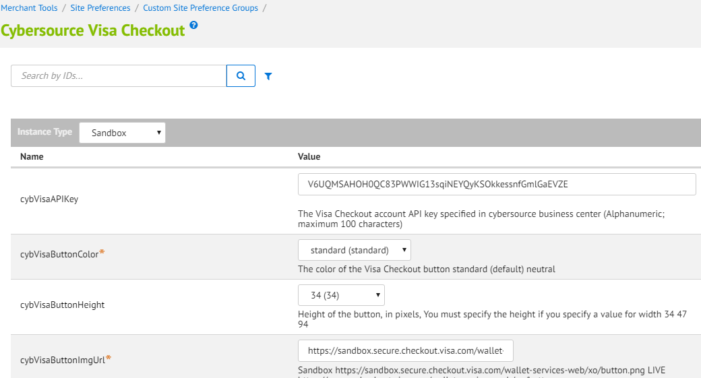

#### Secure Acceptance site preference

##### Site Preferences Attribute

|  |  |  |
| --- | --- | --- |
| **Attribute ID** | **Data Type** | **Description** |
| CsSAOverrideBillingAddress | Boolean | Cybersource Secure Acceptance Override Billing Address |
| CsSAOverrideShippingAddress | Boolean | Cybersource Secure Acceptance Override Shipping Address |
| CsCvnDeclineFlags | Boolean | CyberSource Ignore CVN Result (CVN)  [should be in sync with CYB profile cvn flag] |
| SA_Redirect_AccessKey | String | Secure Acceptance Redirect Access Key |
| SA_Redirect_ProfileID | String | Secure Aceeptance Redirect Profile ID |
| SA_Redirect_SecretKey | String | Secure Acceptance Redirect Secret Key |
| SA_Iframe_AccessKey | String | Secure Acceptance Iframe Access Key |
| SA_Iframe_ProfileID | String | Secure Acceptance Iframe Profile ID |
| SA_Iframe_SecretKey | String | Secure Acceptance Iframe secret key |
| SA_Silent_AccessKey | String | Secure Acceptance Silent Post Access Key |
| SA_Silent_ProfileID | String | Secure Aceeptance Silent Post Profile ID |
| SA_Silent_SecretKey | String | Secure Acceptance Silent Post Secret Key |
| CsSARedirectFormAction | String | Cybersource secure acceptance redirect form action |
| CsSAIframetFormAction | String | Cybersource secure acceptance Iframe form action |
| Secure_Acceptance_Token_Create_Endpoint | String | Secure Acceptance Token Create Endpoint |
| Secure_Acceptance_Token_Update_Endpoint | String | Secure Acceptance Token Update Endpoint |

##### Site Preferences Data

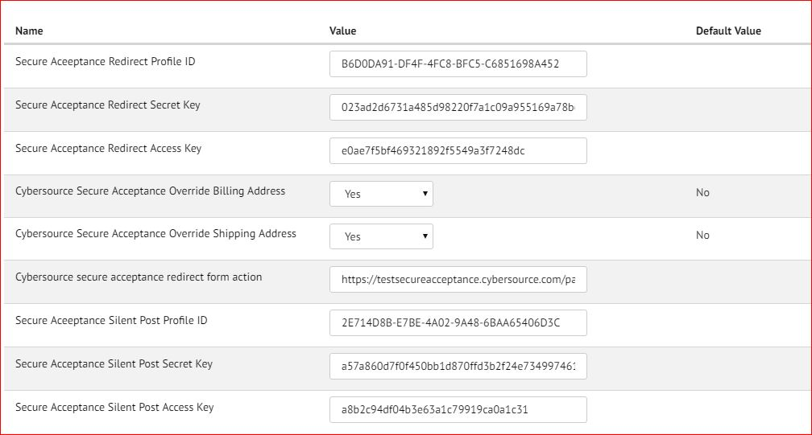

#### Enable Payer Authentication for cards

Update credit card preference through Business Manager >StoreFront Site> Ordering> Payment Methods> Credit Card/Debit Cards > Choose cardand then modify Enable Payer Authentication checkbox

The screen shot below depicts the site preferences configuration:

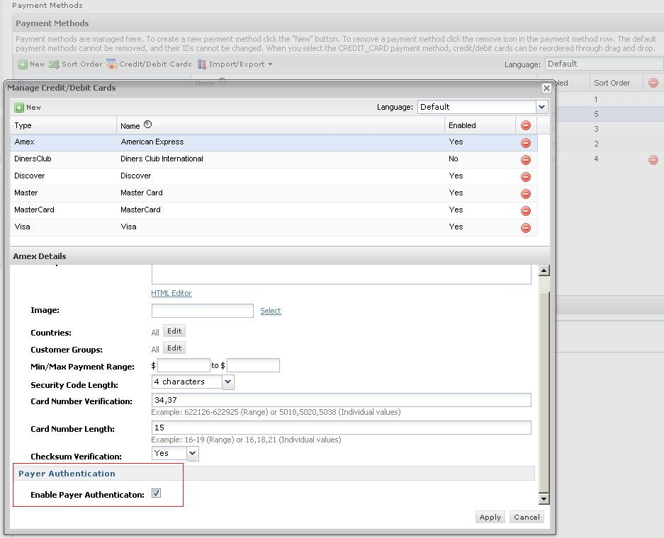

#### Update shipping method preference

Update shipping method preference through Business Manager >StoreFront Site> Ordering> Shipping Methods > Name > CyberSource Shipping ID

The screen shot below depicts the site preferences configuration:

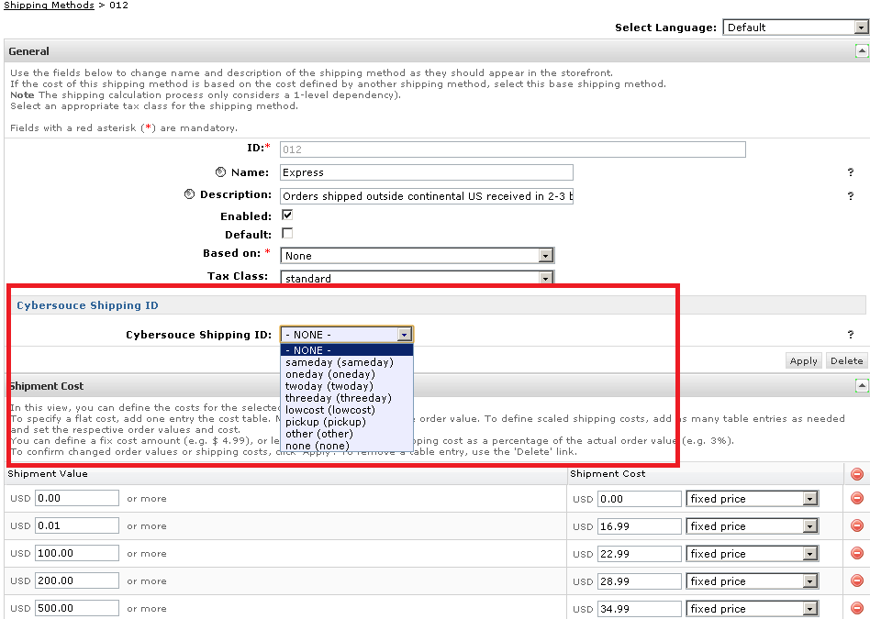

#### Applying CyberSource Cartridge to the Site

Go to the “Administration” in the left hand list to expand the menu and select Sites > Manage Sites link. This will open a list of the active sites on the Demandware platform in your account. Click on the site for which you wish to add the CyberSource cartridge. This will open the General Settings page for that site.

Add int_cybersource cartridges to the BM cartridge path.

Add int_cybersource_controllers and int_cybersource cartridges to the cartridge path as depicted in the following screen:

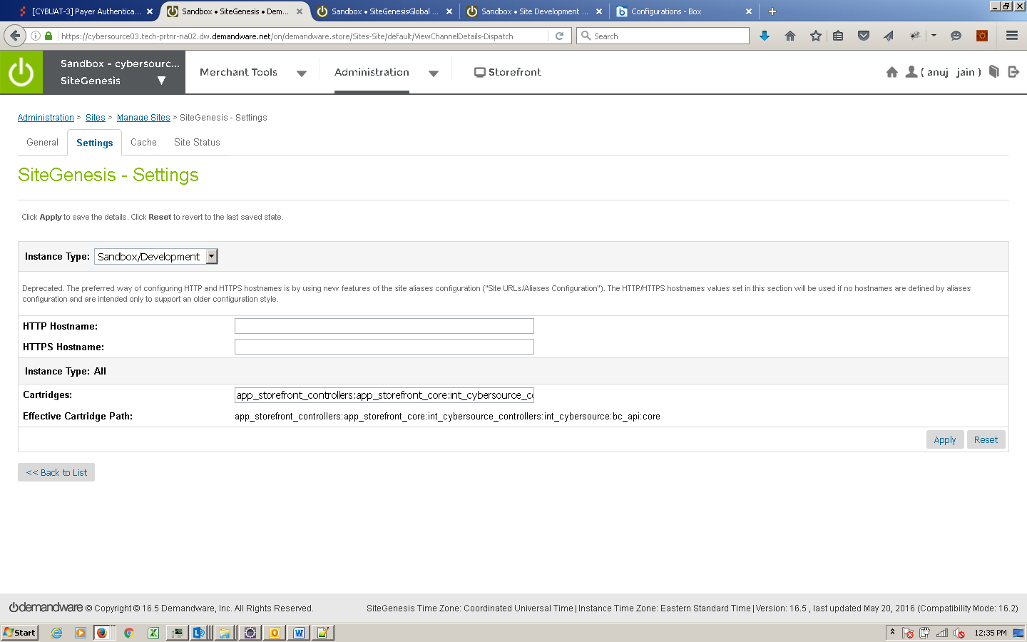

### Batch Jobs

Cybersource cartridge has 3 batch jobs created for different functional items and are placed under int_cybersource cartridge:

To import the following Job Schedule configuration Go Adminsistration > Operations > Import & Export-> upload the below mentioned file and import the configuration.

/int_cybersource/configuration/Cybersource_BatchJobs.xml– this will add below jobs

1. CONVERSION_DETAIL_REPORT_JOB.xml
2. CYBERSOURCE_ALIPAY_JOB.xml
3. SECURE_ACCEPTANCE_JOB.xml

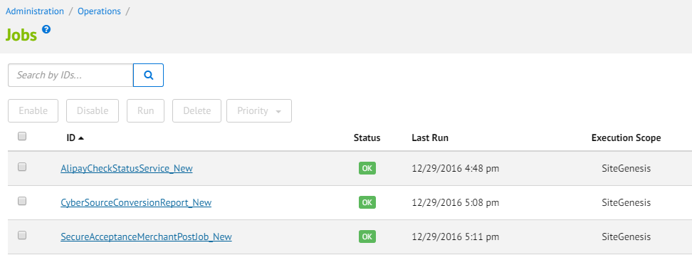

Below steps are used to configured each job in Business manager

#### Batch Job for AliPay

* Add new batch job for Alipay check status service
* Verify the newly added batch jobs for Alipay Check Status Service
* Go to Administration - > Operations -> Job Schedules

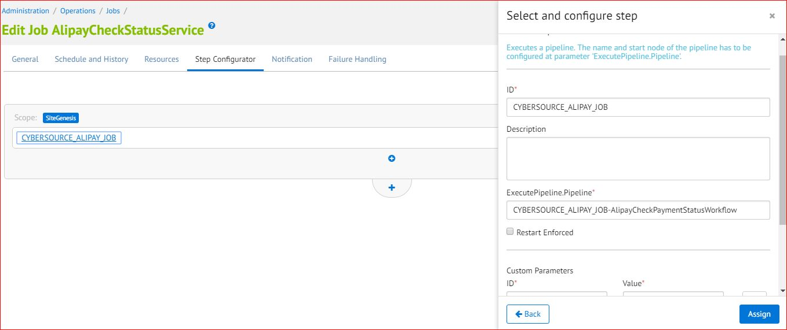

#### Batch Job for Conversion Detail Report

* Add new batch job to update order status in BM for CyberSource “Accepted” & “Rejected” orders.

Verify the newly added batch jobs for Conversion detail report service.

Go to Administration - > Operations -> Job Schedules

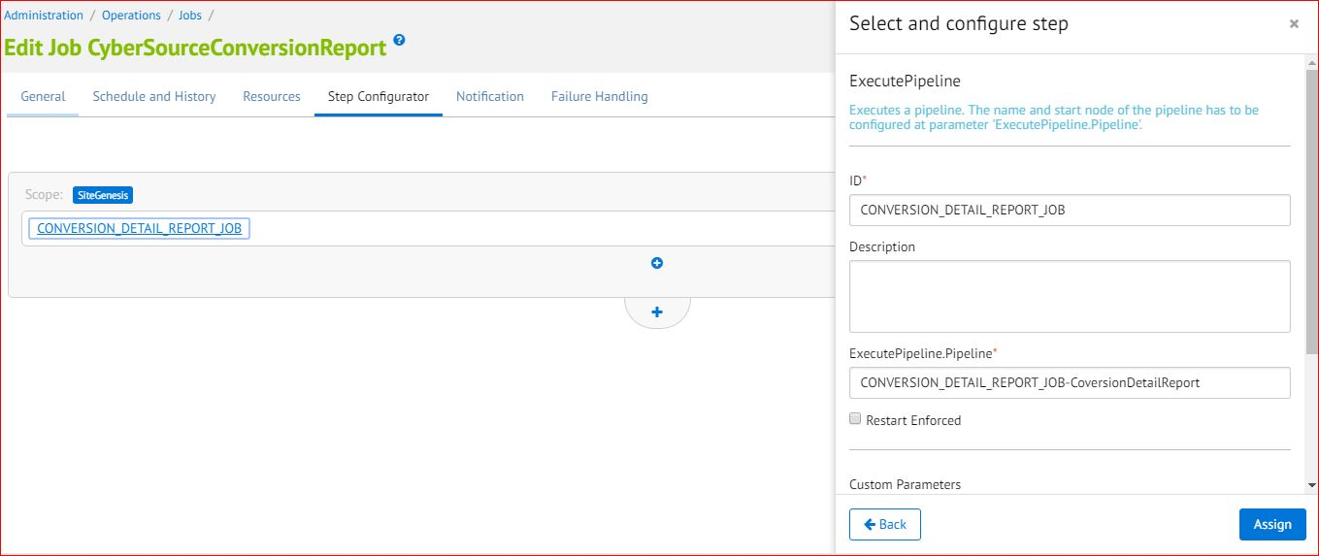

The batch job created for cybersource conversion detail report specified below, it updates the status of order in demandware which are in CREATED state and mark them as “CANCELLED” for rejected order or “NEW” for accepted order. The accepted orders are marked for “READY FOR EXPORT” as well.

#### Secure Acceptance Merchant Post Batch Job

* Add new Service for secure Acceptance Order update via merchant post notifications

After import above file ensure to update credentials as per cybersource merchant account appropriately in BM.

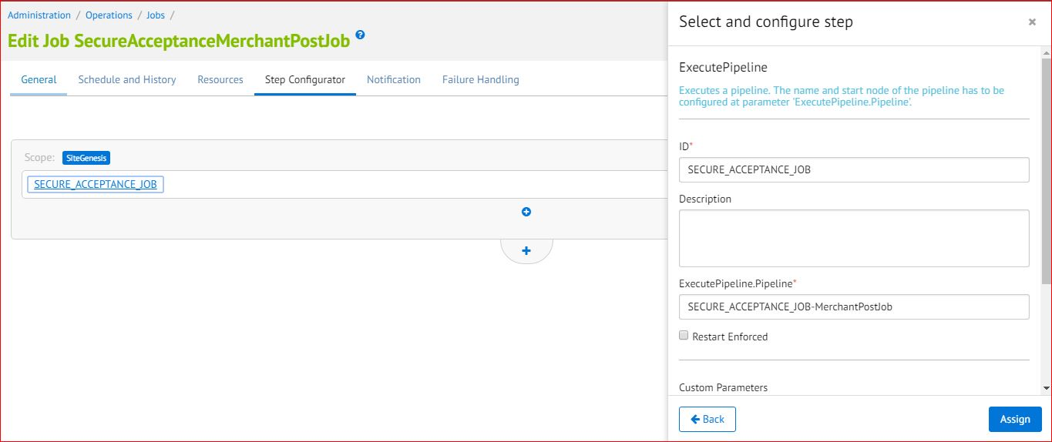

### Secure Acceptance Profile Configuration into CyberSource Business Manager

Secure Acceptance profile settings are configured on CyberSource business center console; along with other settings below are key settings which must be configured in cybersource profiles in order to complete the checkout process successfully.

|  |  |
| --- | --- |
| Profile name | Notification Section [Merchant post URL] |
|
| SA Redirect | [Merchant specific URL]/SECURE_ACCEPTANCE-MerchantPost |
| SA Iframe | [Merchant specific URL]/SECURE_ACCEPTANCE-MerchantPost |
| SA SilentPost | N/A |

Only five types of Card are supported in Demanware, so the cards configured in cybersource payment settings should be in sync with Demandware supported cards

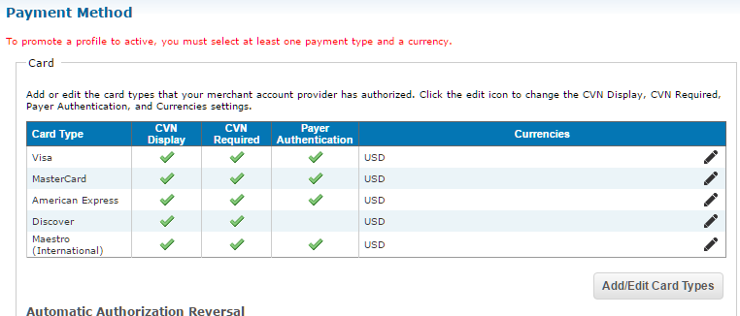

Merchant Notifications POST URL card number digits supported option 2 as shown.

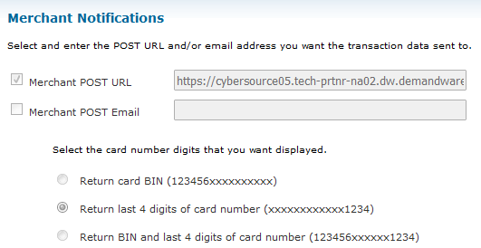

## Unit Test Services

Use CybersourceUnitTest controller to test all the services as follows:

### Authorize Credit Card

Use and modify the CybersourceUnitTest-TestCCAuth controller and associated scripts. The unit test controller displays all relevant request/response information in an easy to digest manner. User can change static credit card and address data to observe various responses.

Modify exports of **CybersourceUnitTest.js TestCCAuth function** with https guard before executing the test case

Example: exports.TestCCAuth=guard.ensure(['https'], TestCCAuth);

### Tax Service

Use and modify the CybersourceUnitTest-TestTax controller and associated scripts. The script for creating CreateCybersourceShipTo and CreateCybersourceBillTo objects have bindings to produce valid results, but otherwise can be manually modified to test against any domestic or international address.

Controller displays all relevant request/response information in an easy to digest manner, to aid the debugging the various response codes and corrected address response.

Modify exports of **CybersourceUnitTest.js TestTax function** with https guard before executing the test case

Example: exports.TestTax=guard.ensure(['https'], TestTax);

### Address Verification Service (AVS)

Use and modify the CybersourceUnitTest-TestCCAuth controller and associated scripts. By running simplified payment authorizations with different site preferences set, you can see how the AVS process works and how that result affects the overall payment authorization process.

Modify exports of **CybersourceUnitTest.js TestCCAuth function** with https guard before executing the test case

Example: exports.TestCCAuth=guard.ensure(['https'], TestCCAuth);

### Delivery Address Verification Service (DAV)

To test standalone DAV service, use and/or modify CybersourceUnitTest-TestDAVCheck and associated scripts. Test data can be customized to simulate various situations that need to be handled.

Modify exports of **CybersourceUnitTest.js TestDAVCheck function** with https guard before executing the test case

Example: exports.TestDAVCheck=guard.ensure(['https'], TestDAVCheck);

### Payment Tokenization

Use the CybersourceUnitTest-StartSubscription controller to start Subscription creation test suite. By entering test data you can use the various Payment Tokenization related services like Create Subscription, View Subscription, Update Subscription, Delete Subscription, Use Subscription for One Time Payment.

Modify exports of **CybersourceUnitTest.js functions like Start, CreateSubscription, ViewSubscription, UpdateSubscription, DeleteSubscription, OnDemandPayment** with https guard before executing the test case

Example: exports. StartSubscription =guard.ensure(['https'], StartSubscription);

### Full Authorization reversal

Use the CybersourceUnitTest-StartAuthReversal controller to start Authorization reversal test suite. By entering test data merchant can use the Cybersource Full Authorization Reversal service.

Modify exports of **CybersourceUnitTest.js functions like StartAuthReversal, Reversal** with https guard before executing the test case

Example: exports.StartAuthReversal=guard.ensure(['https'], StartAuthReversal);

### Device Fingerprint

Call the controller CybersourceUnitTest-TestFingerprint to test the device Fingerprint Service. A CreditCard Authorization is done and a device fingerprint will be additionally submitted.

Modify exports of **CybersourceUnitTest.js TestFingerprint function** with https guard before executing the test case

Example: exports.TestFingerprint=guard.ensure(['https'], TestFingerprint);

### Payer Authentication

Call the controller CybersourceUnitTest-TestPA to test the Payer Authentication Service.

Modify exports of **CybersourceUnitTest.js TestPA function** with https guard before executing the test case

Example: exports.TestPA=guard.ensure(['https'], TestPA);

### Retail POS Authorization Request

Call the controller CybersourceUnitTesting-StartPOS to test the retail POS Service. This renders a template with a form containing various request fields to enter/select values. The service response is shown after the submit button is clicked. The field’s label turns to red colored font if the field was mandatory.

Modify exports of **CybersourceUnitTest.js StartPOS function** with https guard before executing the test case

Example: exports.StartPOS=guard.ensure(['https'], StartPOS);

### Alipay Initiate Request

Call the controller CybersourceUnitTesting-TestAlipayInitiateService to test Alipay Initiate request. Use and modify the mentioned scripts to test initiate request. The end view of the unit test controller is a template which displays all relevant request/response information in an easy to digest manner. User can change static purchase object data and payment type to observe various responses.

Modify exports of **CybersourceUnitTest.js TestAlipayInitiateService function** with https guard before executing the test case

Example: exports.TestAlipayInitiateService=guard.ensure(['https'], TestAlipayInitiateService);

https:// <Sandbox Name>/on/demandware.store/Sites-SiteGenesis-Site/default/CybersourceUnitTesting-TestAlipayInitiatesService

### Alipay Check Status Request

Call the controller CybersourceUnitTesting-TestAlipayCheckStatusService to test Alipay Check Status request. Use and modify the mentioned scripts to test initiate request. The end view of the unit test controller is a template which displays all relevant request/response information in an easy to digest manner.

Modify exports of **CybersourceUnitTest.js TestAlipayCheckStatusService function** with https guard before executing the test case

Example: exports.TestAlipayCheckStatusService=guard.ensure(['https'], TestAlipayCheckStatusService);

https:// <Sandbox Name>/on/demandware.store/Sites-SiteGenesis-Site/default/CybersourceUnitTesting-TestAlipayCheckStatusService?requestId=”Initiate Request Id”

### Credit Card Capture Request

Call the controller CybersourceUnitTesting-TestCaptureCard to test Card Capture request. Use and modify the mentioned scripts to test capture request. The end view of the unit test controller is a template which displays all relevant request/response information in an easy to digest manner.

Modify exports of **CybersourceUnitTest.js TestCaptureCard function** with https guard before executing the test case

Example: exports.TestCaptureCard=guard.ensure(['https'], TestCaptureCard);

https:// <Sandbox Name>/on/demandware.store/Sites-SiteGenesis-Site/default/CybersourceUnitTesting-TestCaptureCard?oid=”Order Number”

### Secure Acceptance Redirect Create Token Test Service Request

Before TESTING please complete the profile setup for service to work refer section **Secure Acceptance profile setup** for more details

Call the controller **CybersourceUnitTest** -TestSATokenCreate to test the secure acceptance redirect create token Service. This renders a secure acceptance hosted page at cybersource having details of card options to choose to enter/select values. The service response is shown after the pay button is clicked.  The field’s label turns to red colored font if the field was mandatory. The response arrived to controller **CybersourceUnitTest** -TestSATokenCreateResponse which displays the service result fields.

Modify exports of **CybersourceUnitTest.js controller TestSATokenCreate and TestSATokenCreateResponse function** with https guard before executing the test case

Example: exports.TestSATokenCreateResponse =guard.ensure(['https'], TestSATokenCreateResponse);

Example: exports.TestSATokenCreate=guard.ensure(['https'], TestSATokenCreate);

### Apple Pay

#### How to test on Demandware server

To test ApplePay on Demandware site, following files need to be updated:

Script – applepay.js

Update the file with below changes:

|  |
| --- |
| **var** Status = require('dw/system/Status');  **var** ApplePayHookResult = require('dw/extensions/applepay/ApplePayHookResult'); |

Add new method getRequest at the end of file

|  |
| --- |
| exports.getRequest = **function** (basket, request) {  **if** (request.shippingContact) {  // convert country code from lower case to upper case  request.shippingContact.countryCode =  request.shippingContact.countryCode.toUpperCase();  }  **return** **new** ApplePayHookResult(**new** Status(Status.OK), **null**);  }; |

Controller – BASIC_CREDIT.js

Update Handle() function with the code below

|  |
| --- |
| /**  * Verifies a credit card against a valid card number and expiration date and possibly invalidates invalid form fields.  * If the verification was successful a credit card payment instrument is created.  */  **function** Handle(args) {  **var** cart = Cart.get(args.Basket);  **var** creditCardForm = app.getForm('billing.paymentMethods.creditCard');  **var** PaymentMgr = require('dw/order/PaymentMgr');  **var** CommonHelper = require('int_cybersource/cartridge/scripts/helper/CommonHelper');  **if** (session.forms.billing.paymentMethods.selectedPaymentMethodID.value.equals('DW_APPLE_PAY')) {  Transaction.wrap(**function** () {  CommonHelper.removeExistingPaymentInstruments(cart);  **var** paymentInstrument = cart.createPaymentInstrument('DW_APPLE_PAY', cart.getNonGiftCertificateAmount());  });  **return** {success:**true**};  }  **var** cardNumber = creditCardForm.get('number').value();  **var** cardSecurityCode = creditCardForm.get('cvn').value();  **var** cardType = creditCardForm.get('type').value();  **var** expirationMonth = creditCardForm.get('expiration.month').value();  **var** expirationYear = creditCardForm.get('expiration.year').value();  **var** paymentCard = PaymentMgr.getPaymentCard(cardType); |

Update Authorize() function with the code below

|  |
| --- |
| /**  * Authorizes a payment using a credit card. The payment is authorized by using the BASIC_CREDIT processor  * only and setting the order no as the transaction ID. Customizations may use other processors and custom  * logic to authorize credit card payment.  */  **function** Authorize(args) {  **var** orderNo = args.OrderNo;  **var** paymentInstrument = args.PaymentInstrument;  **var** paymentProcessor = PaymentMgr.getPaymentMethod(paymentInstrument.getPaymentMethod()).getPaymentProcessor();  Transaction.wrap(**function** () {  paymentInstrument.paymentTransaction.transactionID = orderNo;  paymentInstrument.paymentTransaction.paymentProcessor = paymentProcessor;  });  **if** (session.forms.billing.paymentMethods.selectedPaymentMethodID.value.equals('DW_APPLE_PAY')) {  **return** {review:**true**};  }  **return** {authorized: **true**};  } |

Hooks.json

Add hook for applepay at the end of file

|  |
| --- |
| ,  {  "name": "dw.extensions.applepay.getRequest",  "script": "./checkout/applepay.js"  } |

[Note: this change is for testing purpose only]

#### Rest Interface Testing

The Interface can be tested via any REST client like SOAPUI etc. Below are the steps to test the REST service

1. Install the REST client on machine or browser
2. Hit the secure End Point URL as POST request having merchant site URL for “Cybersource_ApplePay-Authorize” [example: https://<merchant sandbox>/on/demandware.store/Sites-<merchant site>-Site/default/Cybersource_ApplePay-Authorize]
3. Add key-value pairs in header for credentials

|  |  |
| --- | --- |
| **HEADER KEY** | **HEADER VALUE** |
| dw_applepay_user | User is configured by merchant in demandware platform under site preferences |
| dw_applepay_password | Password is configured by merchant in demandware platform under site preferences. Further the password to be base64 encode before passing to REST interface |
| Content-Type | application/json |

1. Pass below JSON when Payload test data available

|  |  |
| --- | --- |
| **JSON KEY** | **JSON VALUE** |
| orderID | The order ID of ApplePay order object created during checkout journey of ApplePay |
| encryptedPaymentBlob | Encrypted ApplePay blob data returned by ApplePay for PSP to place the order. This contains billing/shipping/card details in encrypted form. |

1. Pass below JSON when Network Token test data available

|  |  |
| --- | --- |
| **JSON KEY** | **JSON VALUE** |
| orderID | The order ID of ApplePay order object created during checkout journey of ApplePay |
| networkToken | Network Token returned by ApplePay for PSP authorization (Max length 20 character) |
| cardType | Card Type returned by ApplePay for PSP authorization. Supported types visa/mastercard/amex |
| tokenExpirationDate | Network Token Expiration Date returned by ApplePay for PSP authorization. Format YYMMDD |
| cryptogram | Cryptogram encoded form (max length 40 character) |

1. Test the Success response JSON

|  |  |
| --- | --- |
| **JSON KEY** | **JSON VALUE** |
| TRANSACTION_RESULT | Below json key-value pairs |
| DECISION | Possible values ACCEPT | REVIEW | REJECT | ERROR | CANCEL |
| REASON_CODE | ReasonCode |
| REQUEST_ID | RequestID |
| REQUEST_TOKEN | RequestToken |
| AUTHORIZATION_AMOUNT | AuthorizationAmount |
| AUTHORIZATION_CODE | AuthorizationCode |
| AUTHORIZATION_REASON_CODE | AuthorizationReasonCode |
| DAV_REASON_CODE | DAVReasonCode |
| RAW_SERVICE_RESPONSE | Entire service response in form of JSON |

1. Test the Validation/Failure response JSON

|  |  |
| --- | --- |
| **JSON KEY** | **JSON VALUE** |
| ERROR_CODE | Validation failure error code of interface |
| ERROR_MSG | Validation failure message of interface |

##### Sample ApplePay InterfaceJSON Request /Response format

Interface 1: Request with network Token and Cryptogram data:

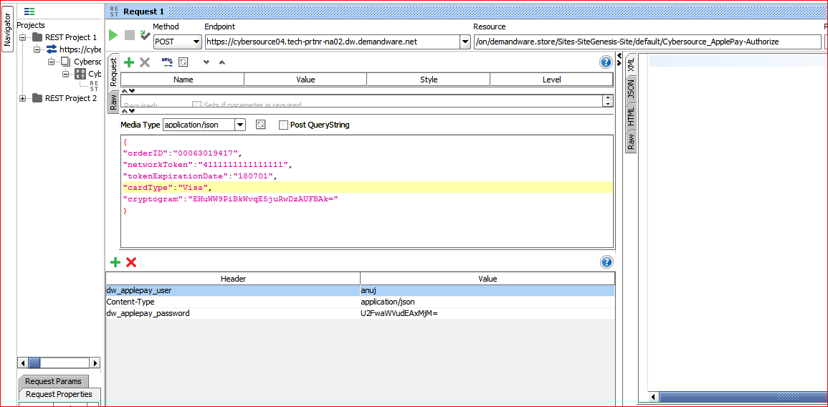

**Interface2:** Request with encrypted payment BLOB data.

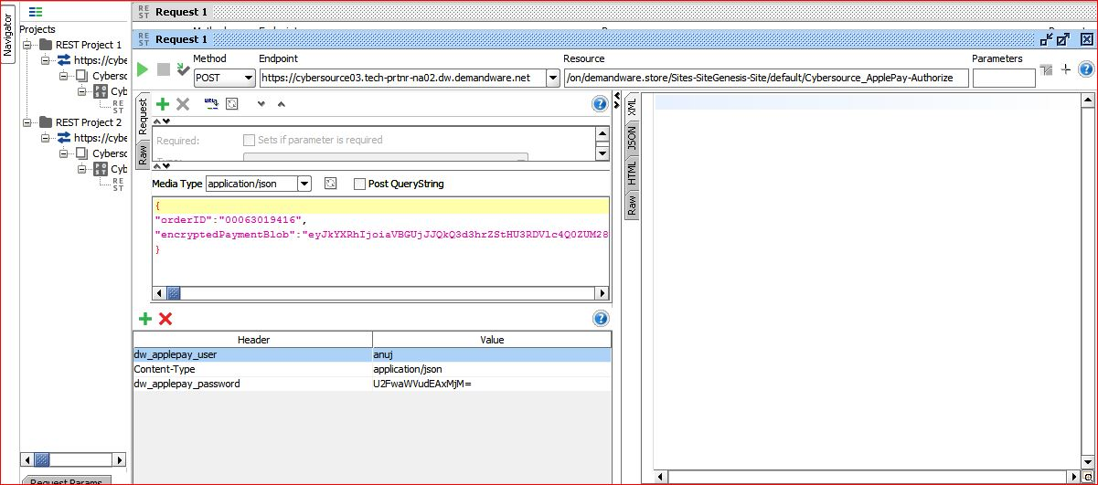

## Cartridges Structure and Reference

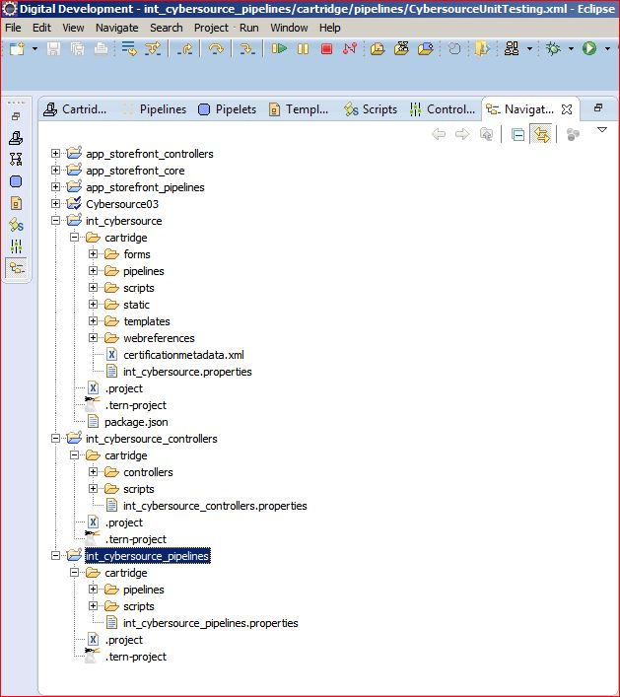

# Typical Project Plan

## Roles, Responsibilities

Typically most of the integration works is done by the backend developer. We expect that the person doing this integration is familiar with the web service, xml processing and has hands on experience with the Demandware platform.

## Typical Efforts and Timelines

The level of effort is mostly detected by the services merchant may choose from the CyberSource cartridge. The

|  |  |  |
| --- | --- | --- |
| **CyberSource Service** | **Level of Effort (LOE)** | **Dependencies** |
| Initial Cartridge Setup | **0.5**– Person Day  List of tasks involved:   * Add CyberSource Cartridges to the project * Import Configuration files as specified in configuration section | * Cartridge is available |
| Authorize Credit Card | **0.5**– Person Day  List of tasks involved:   * Integrate CyberSource-AuthorizeCreditCard controller with COPlaceOrder. | * Merchant ID and Key is established for the client. * Site Preferences for authorization configured with above ID and Key. |
| Device Fingerprint (as addition to Authorize Credit Card) | **0.5** Person Day | * Enable Device Fingerprint, set Organization ID * Add include at billing page. |
| Address Verification Service (AVS)* | **0.5**– Person Day | * Initial Cartridge Setup |
| Delivery Address Verification (DAV)* | **0.5**– Person Day | * Initial Cartridge Setup |
| Decision Manager | **0.5**– Person Day | * Access to Decision Manager. * Business rules are defined. * Order status notification URL pointing to Cybersource-NewDecision is defined. |
| Payment Tokenization* | **0.5**– Person Day  +  Depends on customization needs | * Initial Cartridge Setup |
| Payer Authentication | **1.5**– Person Day | * Initial Cartridge setup * Update CoPlaceOrder-HandlePayments * Handle error scenarios in merchant specific ways |
| Alipay Integration on Payment Page | **1.0**– Person Day | * Initial Cartridge setup * Update CoPlaceOrder-HandlePayments * Handle error scenarios in merchant specific ways |
| Visa Checkout | **0.5**– Person Day  List of tasks involved:  Integrate VISACHECKOUT controller and merchant site specific button injection on minicart, cart and billing page. | * Merchant ID and Key is established for the client. * Visa checkout account setup requried * Site Preferences for authorization configured with above ID and Key. |
| Apple Pay | **2**– Person Day  List of tasks involved:  Choose and decide the integration mechanism with applepay interface. | * Site Preferences for heder authentication exposed. |
| Secure Acceptance (Redirect/Iframe/Silent post) | **0.5**– Person Day (1 out of 3 methods)  List of tasks involved:  Integrate SECURE_ACCEPTANCE Controller | * Cartridge setup * Configure profile and URL in Cybersource * Site preference configuration in Demandware Business manager * config |

*Note that because customized user interface elements are completely dependent on merchant specification, the time required to interact with the customer to correct address information or confirm standardized address format corrections, is not included; only the time required to integrate with the web services is included, with minimal testing and simplified validation handling, ie. Automatically make correction to a customer address, as per validation response.

## Pre-Production Steps

In order to avoid misuse of unit testing controller methods on production instances it is advised to make following **controller function export guard to be removed** before pushing code to production instances.

CybersourceUnitTesting-TestCCAuth

CybersourceUnitTesting- TestAlipayInitiateService

CybersourceUnitTesting- TestAlipayCheckStatusService

CybersourceUnitTesting-TestTax

CybersourceUnitTesting-TestDAVCheck

CybersourceUnitTesting-TestPA

CybersourceUnitTesting-TestFingerprint

CybersourceUnitTesting -StartSubscription

CybersourceUnitTesting -CreateSubscription

CybersourceUnitTesting -ViewSubscription

CybersourceUnitTesting -UpdateSubscription

CybersourceUnitTesting -DeleteSubscription

CybersourceUnitTesting -OnDemandPayment

CybersourceUnitTesting-StartAuthReversal

CybersourceUnitTesting-StartReversal

CybersourceUnitTesting-StartPOS

CybersourceUnitTesting- TestSATokenCreate

# Known Issues

1. Incase of setting Ignore AVS Result custom preference to true, there can be a known issue as described below:

If the AVS response code received as N, the cartridge ignores the ccAuthReply reason code and processes the transaction under “review” status. This can lead to an ambiguous situation when the Credit Card was rejected, but due to the AVS code as “N”, the cartridge continued with order processing and successful order placement.

1. Testing of Alipay is possible only with Test data provided by CyberSource such as Reconciliation ID that is getting passed to Alipay Initiate Service to get the response back. We don’t have Alipay simulator and access to Alipay live environment.

# CyberSource document links

1. <http://www.cybersource.com/support_center/implementation/testing_info/simple_order_api/General_testing_info/soapi_general_test.html>
2. <http://www.cybersource.com/support_center/support_documentation/quick_references/view.php?page_id=422>
3. <http://apps.cybersource.com/library/documentation/dev_guides/CC_Svcs_SO_API/Credit_Cards_SO_API.pdf> - Page 163 - Appendix C.
4. <http://apps.cybersource.com/library/documentation/dev_guides/Getting_Started/Getting_Started_Advanced.pdf>
5. <http://www.cybersource.com/support_center/support_documentation/quick_references/>
6. <http://apps.cybersource.com/library/documentation/dev_guides/Payer_Authentication_IG/20090928_Payauth_IG.pdf>
7. <http://apps.cybersource.com/library/documentation/dev_guides/Payer_Authentication_IG/html/>
8. <http://apps.cybersource.com/library/documentation/dev_guides/Verification_Svcs_IG/20091012_Verification_IG.pdf>
9. <http://www.cybersource.com/support_center/support_documentation/services_documentation/tax.php>
10. <http://apps.cybersource.com/library/documentation/dev_guides/Tax_IG/Tax_Guide.pdf>
11. <http://apps.cybersource.com/library/documentation/dev_guides/Retail_SO_API/Retail_SO_API.pdf>
12. <http://apps.cybersource.com/library/documentation/dev_guides/AliPayDom/AliPay_Dom_SO_API.pdf>
13. <http://apps.cybersource.com/library/documentation/dev_guides/AliPayInt/AliPay_Int_SO_API.pdf>
14. http://apps.cybersource.com/library/documentation/dev_guides/apple_payments/SO_API/Apple_Pay_SO_API.pdf
15. http://apps.cybersource.com/library/documentation/dev_guides/Secure_Acceptance_WM/Secure_Acceptance_WM.pdf
16. http://apps.cybersource.com/library/documentation/dev_guides/Secure_Acceptance_SOP/Secure_Acceptance_SOP.pdf
17. <http://apps.cybersource.com/library/documentation/dev_guides/VCO_SO_API/Visa_Checkout_SO_API.p>df

# Release History

|  |  |  |
| --- | --- | --- |
| Version | Date | Changes |
| 1.0.0.1 | 02/02/2010 | Initial release |
| 1.0.0.2 | 02/08/2010 | Device Fingerprint Feature added |
| 1.0.0.3 | 03/01/2012 | Updated Tax pipeline to remove unnecessary / redundant tax requests to reduce tax service charges. |
| 1.0.0.4 | 12/18/2012 | Updated Tax pipeline to remove redundant tax requests by using SkipTaxCalculation parameter |
| 1.1.0 | 01/16/2013 | Incorporated review comments from Demandware team |
| 1.1.0 | 02/06/2013 | Incorporated New changes as per new Site Genesis code |
| 2.0.0 | 09/23/2013 | V.me support changes added. Removed deprecated method setGrossPrice for taxation |
| 2.1.0 | 10/04/2013 | V.me Clickjacking changes added |
| 2.1.1 | 11/04/2013 | Removed unsued code from pipeline |
| 2.1.2 | 04/25/2014 | RSA key removed from the cartridge. Bug fixed related to promotional discount. |
| 2.1.3 | 05/29/2014 | Retail Point of Sale (POS) API added |
| 14.2.1 | 08/04/2014 | Document version updated |
| 15.0 | 03/25/2015 | Alipay, Paypal Express and Paypal implementation |
| 15.1.0 | 04/15/2015 | Changes done for Taxation service call and other Changes related to Credit Card and BML. V.me support changes and V.me Clickjacking changes removed. |
| 16.1.0 | 05/30/2016 | Changes done for Controller AsWrapper to call pipeline flows, defects fixes and change request |
| 17.1 | 01/02/2017 | Removed:   * BML * Removed PayPal Express support   Added :   * Visa Checkout * Secure Acceptance Web/Mobile [Redirect/Iframe] * Secure Acceptance Silent Order Post * Apple Pay REST Interface |